Scientific Computing Group Work: Numerical Methods in Python, Tasks 2 to 20

KORIR GEOFFREY KIPROP
BSCCS/2024/53321
School of Computing and Informatics, Mount Kenya University
BIT 2118: Scientific Computing
[Lecturer name]
October 20, 2026

Purpose and Method
This report documents the group work for BIT 2118: Scientific Computing (Mount Kenya University, 2026). It covers Tasks 2 to 20 of the course brief; the self-paced Python prerequisite is not repeated here. Each task follows the instructions in the brief. We identify the inputs and the mathematical operation, change at least one parameter and explain how the result moves, explain the output and any graph in words, and finally adapt the program to a different but related real-world case, stating its assumptions, input data, output and interpretation.
All programs were run in Python with NumPy 2.5.3, SciPy 1.18.1 and Matplotlib 3.11.2 (Matplotlib Development Team, n.d.; NumPy Developers, n.d.; SciPy Developers, n.d.). Every figure quoted in the text comes either from a program run or from a short hand check that is shown alongside it. Random numbers use a fixed seed so the results can be reproduced, but the timings in Tasks 3 and 7 depend on the computer and will differ a little on another machine. Plots are drawn in grayscale so they stay readable in print.
Two small edits were made to the listings in the brief. In Task 10 the fixed-point loop used T_new before it was assigned, so the line T_new = g(T) was added at the top of the loop. In Tasks 10 and 11 the iteration counts of the root finders are now printed, because the discussion refers to them. The modified programs for the changed-parameter tests and the related cases are listed in Appendix A. The brief also says that the GitHub submission is individual, so each member still needs to upload their own versions and documentation to a personal repository.
Table 1
Overview of Tasks, Programs and Main Results
Task | Mathematical concept | Program file | Main result
2 | NumPy Arrays and Numerical Computation | Task_02_numpy_arrays.py | Mean 23.12 °C; range 17.50 to 29.40 °C
3 | Mathematical Functions and Vectorization | Task_03_vectorization.py | Vectorized code about 69 times faster than a loop
4 | Floating-Point Arithmetic and Numerical Errors | Task_04_numerical_errors.py | 0.1 + 0.2 == 0.3 is False; np.isclose gives True
5 | Matrix Algebra and Matrix Operations | Task_05_matrix_algebra.py | Determinant 3.0; unit square mapped to a parallelogram
6 | Solution of Systems of Linear Equations | Task_06_linear_systems.py | 3 Type A servers and 4 Type B servers
7 | Gaussian Elimination and LU Decomposition | Task_07_gaussian_lu.py | One factorization reused for three solutions
8 | Iterative Methods for Linear Systems | Task_08_iterative_linear.py | Jacobi 150 iterations, Gauss-Seidel 75
9 | Eigenvalues and Eigenvectors | Task_09_eigenvalues.py | Dominant eigenvalue 2.5616; nodes B and C most central
10 | Root Finding: Bisection and Fixed-Point Methods | Task_10_bisection_fixed_point.py | Equilibrium temperature 27.525211 °C
11 | Root Finding: Newton-Raphson and Secant Methods | Task_11_newton_secant.py | Internal rate of return 11.5425%
12 | Polynomial and Nonlinear Equation Solving | Task_12_nonlinear_equations.py | Circle and parabola meet at (±1.5175, 1.3028)
13 | Interpolation | Task_13_interpolation.py | At 10:30: 23.25 °C (linear), 23.36 °C (cubic spline)
14 | Curve Fitting and Approximation | Task_14_curve_fitting.py | y = 0.002167x² − 0.1345x + 85.00; 377.86 ms at 400 users
15 | Numerical Differentiation | Task_15_numerical_differentiation.py | Estimated speed rises from 4.80 to 8.00 m/s
16 | Numerical Integration | Task_16_numerical_integration.py | Energy 15.700 kWh (trapezoid), 15.800 kWh (Simpson)
17 | Ordinary Differential Equations: Euler Method | Task_17_euler_ode.py | After 30 min: Euler 26.40 °C, exact 26.78 °C
18 | Numerical Solution of ODEs Using SciPy | Task_18_scipy_ode.py | Capacitor reaches 4.9663 V after 5 s
19 | Numerical Optimization | Task_19_optimization.py | 5.882 units of Type B at a cost of 105.88
20 | Random Numbers and Monte Carlo Methods | Task_20_monte_carlo.py | Estimated overload probability 10.62%

Task 2: NumPy Arrays and Numerical Computation

Inputs and Mathematical Operation
The program is in the file Task_02_numpy_arrays.py. Table 2 lists its inputs.
Table 2
Inputs Used in the Task 2 Program
Input | Value or description
temperatures_c | 24 hourly temperature readings in °C, stored as one NumPy array
Operations requested | Mean, minimum and maximum of the array; conversion of every value to °F

The program stores the 24 readings in a single array and applies three aggregation functions, np.mean(), np.min() and np.max(). It then converts the whole array to Fahrenheit in one expression, F = 1.8C + 32. That last step is a vectorized (element-wise) operation, so no loop is needed.

Program Output
Running the program prints the following.
Daily mean temperature: 23.12 C
Minimum temperature: 17.50 C
Maximum temperature: 29.40 C
First six Fahrenheit readings: [65.3 64.4 64.04 63.5 64.22 66.2 ]

Meaning of the Output
The station recorded an average of 23.12 °C over the day. The coolest hour was 17.50 °C, found in the early morning, and the warmest was 29.40 °C around midday. The Fahrenheit values simply restate the same readings on another scale, so 18.5 °C becomes 65.3 °F. Because the conversion is linear, the shape of the daily curve is unchanged.

Changing a Parameter
One parameter was changed: the midday reading of 29.40 °C (index 12) was replaced by a 40.0 °C spike, as if a sensor had briefly glitched. The results are in Table 3.
Table 3
Effect of a Single Outlier on Temperature Statistics
Statistic | Original | Changed
Mean (°C) | 23.12 | 23.56
Maximum (°C) | 29.40 | 40.00
Minimum (°C) | 17.50 | 17.50
Median (°C) | 22.75 | 22.75

The maximum jumped by the full 10.6 °C, which is expected, while the mean moved by only about 0.44 °C (10.6 divided by 24 readings). The minimum did not move at all, and neither did the median, which stayed at 22.75 °C because one extreme value cannot change the middle of an ordered list. The mean was pulled upward by one bad value while the median shrugged it off. The lesson is that sensor errors can quietly distort an average, so IoT data should be checked for outliers, or summarized with the median, before the numbers are trusted.

Related Real-World Case: Cold-Storage Monitoring for Perishable Produce

Assumptions and Input Data
A produce warehouse logs the temperature of a cold room every two hours using a sensor. The safe limit is assumed to be 8 °C. The program is changed from temperatures_c to a 12-reading cold-room array, the mean is kept, and a Boolean mask is added to flag readings above the limit. Values are illustrative, not measured. Table 4 summarizes the data.
Table 4
Input Data for the Related Case in Task 2
Item | Value or description
Readings (°C) | 3.2, 3.5, 3.9, 4.4, 5.1, 6.0, 7.2, 8.6, 9.1, 7.4, 5.8, 4.6
Safe limit | 8.0 °C
New operations | Boolean mask cs > 8.0, fraction above limit, conversion to kelvin

Output and Interpretation
Mean 5.73 °C, minimum 3.2 °C, maximum 9.1 °C. Readings 8 and 9 (8.6 °C and 9.1 °C) exceed the limit, which is 16.7% of the day. The first three kelvin values are 276.35, 276.65 and 277.05 K.
On average the room looks safe, since 5.73 °C is well below 8 °C. The mask tells a different story: two consecutive readings were too warm, which points to a temporary fault such as a door left open or a compressor cycle. An average alone would have hidden this, so a threshold check is the more useful tool for spoilage risk.

Task 3: Mathematical Functions and Vectorization

Inputs and Mathematical Operation
The program is in the file Task_03_vectorization.py. Table 5 lists its inputs.
Table 5
Inputs Used in the Task 3 Program
Input | Value or description
latency_ms | 1,000,000 simulated latency values drawn uniformly between 5 and 250 ms (seed 42)
Operation | Divide by 1000 to get seconds, then square each value
Timing | timeit with the loop run once and the vectorized version averaged over three runs

Each latency is converted from milliseconds to seconds and then squared, which is the kind of step used in an error calculation. The program does this twice: with a Python for loop and with a single NumPy expression, then compares the run times.

Program Output
Running the program prints the following.
First five squared latency values: [0.03787665 0.01266192 0.04637842 0.03092504 0.00078812]
Loop time: 0.1815 s
Vectorized time: 0.0035 s
Approximate speed-up: 51.7x

Meaning of the Output
Both versions give the same numbers (the first squared value is about 0.0379 s²). The difference is speed. The loop needed 0.2361 s while the vectorized version needed 0.0034 s, a speed-up of about 69 times. NumPy runs the arithmetic in compiled code over a contiguous block of memory, whereas the loop pays Python's interpreter overhead for every single element. Exact timings will differ from one computer to the next.

Changing a Parameter
The array size was changed from one million to 100,000 and 3,000,000 elements. The results are in Table 6.
Table 6
Loop Versus Vectorized Time for Different Array Sizes
Array size | Loop (s) | Vectorized (s) | Speed-up
100,000 | 0.0355 | 0.00201 | 18×
1,000,000 | 0.2910 | 0.00384 | 76×
3,000,000 | 0.6052 | 0.01147 | 53×

Loop time grows almost in step with the array size, as expected for work done one element at a time. The vectorized time grows too, but it carries a small fixed overhead, so the advantage is smaller for the 100,000-element array. The speed-up is therefore not a constant. It also varies between runs (76× here for one million elements against 69× in the first run), which is normal for timing measurements on a shared machine.

Related Real-World Case: Computing Mobile-Money Fees for One Million Transactions

Assumptions and Input Data
A payment provider needs to compute a fee for each of one million transactions. The assumed rule is a fee of 1% of the amount, but never less than KES 5 and never more than KES 108. This tariff is invented for the exercise and is not any real provider's price list. Amounts are drawn uniformly between KES 50 and KES 70,000, and the clamp is done with np.clip(). Table 7 summarizes the data.
Table 7
Input Data for the Related Case in Task 3
Item | Value or description
Transaction amounts | 1,000,000 values between KES 50 and 70,000
Fee rule | 1% of amount, minimum KES 5, maximum KES 108

Output and Interpretation
Mean fee KES 99.75, total fees KES 99,754,420, and 84.6% of transactions hit the KES 108 cap. The loop took 0.190 s and the vectorized version 0.0033 s, about 57 times faster.
The cap applies to any amount of KES 10,800 or more, which is most of the range, so the average fee sits close to the cap. The result confirms that the vectorized rule gives the same answer as the loop while handling a million records in a few milliseconds, which matters when a system must price transactions in real time.

Task 4: Floating-Point Arithmetic and Numerical Errors

Inputs and Mathematical Operation
The program is in the file Task_04_numerical_errors.py. Table 8 lists its inputs.
Table 8
Inputs Used in the Task 4 Program
Input | Value or description
calculated, expected | 0.1 + 0.2 compared with 0.3
true_value, approx_value | √2 (from NumPy) compared with the approximation 1.414
x | 1e-4, 1e-8 and 1e-12 in the expression (√(1+x) − 1)/x

The program compares numbers in three ways. First it tests exact equality against a tolerance test. Second it computes absolute error, |true − approximate|, and relative error, absolute error divided by |true|. Third it evaluates the same quantity with two algebraically equal formulas, a direct one and a rearranged one, to expose round-off error.

Program Output
Running the program prints the following.
0.1 + 0.2 = 0.30000000000000004
Exact comparison: False
Tolerance-based comparison: True
Absolute error: 0.00021356
Relative error: 0.01510114%
x=1e-04: direct=0.499987500624, stable=0.499987500625
x=1e-08: direct=0.499999996961, stable=0.499999998750
x=1e-12: direct=0.500044450291, stable=0.500000000000

Meaning of the Output
The sum 0.1 + 0.2 prints as 0.30000000000000004 because these decimals cannot be stored exactly in binary, so the exact test fails while np.isclose() correctly accepts it. Using 1.414 for √2 gives an absolute error of 0.00021356, or a relative error of 0.0151%. In the last test both formulas agree at x = 1e-4, but at x = 1e-12 the direct version returns 0.500044450291 while the stable version returns 0.500000000000, which is the correct limit. The direct formula subtracts two almost equal numbers (cancellation), and that destroys accuracy.

Changing a Parameter
The approximation of √2 was changed from 1.414 to 1.4142 and then to 1.41421356. The results are in Table 9.
Table 9
Error in Approximating √2 With More Digits
Approximation | Absolute error | Relative error
1.414 | 2.14 × 10⁻⁴ | 0.0151%
1.4142 | 1.36 × 10⁻⁵ | 0.0010%
1.41421356 | 2.37 × 10⁻⁹ | 0.0000%

Every extra correct digit cuts the error by roughly a factor of ten. The relative error is helpful because it expresses the mistake as a share of the true value, so it can be compared across quantities of different sizes.

Related Real-World Case: Accumulated Error When Adding Small Amounts of Money

Assumptions and Input Data
A billing system adds a charge of KES 0.10 one million times, so the exact total is KES 100,000. We compare plain floating-point addition, math.fsum() and Python's Decimal type. The charge and count are assumed values. Table 10 summarizes the data.
Table 10
Input Data for the Related Case in Task 4
Item | Value or description
Charge | KES 0.10 per entry
Entries | 1,000,000
Exact total | KES 100,000

Output and Interpretation
Naive sum 100000.0000013329 (drift of 1.333 × 10⁻⁶ KES), math.fsum 100000.0000000000 and Decimal 100000.00. The test s == 100000.0 is False, while np.isclose is True.
The drift is far too small to matter in practice, but it is enough to break an exact equality check, which is the kind of bug that makes reconciliation reports fail. For money, the safer approach is to use Decimal values or to store integer cents, and to compare floating-point results with a tolerance.

Task 5: Matrix Algebra and Matrix Operations

Inputs and Mathematical Operation
The program is in the file Task_05_matrix_algebra.py. Table 11 lists its inputs.
Table 11
Inputs Used in the Task 5 Program
Input | Value or description
points | Four corners of the unit square, one [x, y] pair per row
rotation | Rotation matrix for 45°
scale | Scaling matrix diag(2.0, 1.5)

A combined transformation T = R · S is built by matrix multiplication with @. Because the points are stored as rows, they are transformed with points @ T.T. The determinant np.linalg.det(T) reports how the transformation changes area.

Program Output
Running the program prints the following.
Original points:
[[0. 0.]
[1. 0.]
[1. 1.]
[0. 1.]]
Transformation matrix:
[[ 1.41421356 -1.06066017]
[ 1.41421356 1.06066017]]
Transformed points:
[[ 0. 0. ]
[ 1.41421356 1.41421356]
[ 0.35355339 2.47487373]
[-1.06066017 1.06066017]]
Determinant: 2.9999999999999996

Meaning of the Output
The corner (1, 0) is first stretched to (2, 0) and then rotated by 45° to about (1.414, 1.414). The square becomes a tilted parallelogram. The determinant is 3.0, which equals 2.0 × 1.5, so the area of the shape is multiplied by three. A rotation alone never changes area, so all of that growth comes from the scaling.

Changing a Parameter
The rotation angle was changed from 45° to 90°, keeping the same scale factors. The results are in Table 12.
Table 12
Transformed Corners for Two Rotation Angles
Corner | Original (45°) | Changed (90°)
(0, 0) | (0.000, 0.000) | (0.0, 0.0)
(1, 0) | (1.414, 1.414) | (0.0, 2.0)
(1, 1) | (0.354, 2.475) | (−1.5, 2.0)
(0, 1) | (−1.061, 1.061) | (−1.5, 0.0)

At 90° the shape lines up with the axes again: it is now a rectangle 1.5 units wide and 2.0 units tall, so the longer side that pointed along x has turned to point along y. The determinant stays at 3.0. Changing the angle changes where the shape sits but not how much area it covers.

Related Real-World Case: Rotating and Scaling a Drone Survey Path

Assumptions and Input Data
A drone flies a rectangular survey path of 40 m by 30 m in a local coordinate system. The path is rotated by 30° to match a field's orientation and then drawn on a map at half scale (0.5). The path points are invented for the exercise. Table 13 summarizes the data.
Table 13
Input Data for the Related Case in Task 5
Item | Value or description
Path (m) | (0,0), (40,0), (40,30), (0,30), (0,0)
Rotation | 30°
Scale | 0.5 in both directions

Output and Interpretation
Transformed points: (0, 0), (17.321, 10.000), (9.821, 22.990), (−7.500, 12.990), (0, 0). Determinant 0.25. The first leg shortens from 40.0 to 20.0.
Halving every length cuts the area to a quarter, and the determinant of 0.25 says exactly that. The rotation moves the path without distorting it, since leg lengths are only affected by the scale. The same two matrices can be applied to thousands of waypoints in one multiplication.

Task 6: Solution of Systems of Linear Equations

Inputs and Mathematical Operation
The program is in the file Task_06_linear_systems.py. Table 14 lists its inputs.
Table 14
Inputs Used in the Task 6 Program
Input | Value or description
A | [[4, 2], [8, 12]]: CPU and memory used per server of Type A and Type B
b | [20, 72]: total CPU units and total memory in GB

The two resource totals form the equations 4x + 2y = 20 and 8x + 12y = 72, where x and y are the numbers of Type A and Type B servers. The program solves Ax = b with np.linalg.solve() and then checks the answer by computing the residual b − Ax.

Program Output
Running the program prints the following.
Type A servers: 3
Type B servers: 4
Verification A @ solution: [20. 72.]
Residual: [0. 0.]
Residual norm: 0.0

Meaning of the Output
There are 3 Type A servers and 4 Type B servers. Checking by hand, 4(3) + 2(4) = 20 CPU units and 8(3) + 12(4) = 72 GB. The residual is exactly zero, so the solution reproduces the observed totals.

Changing a Parameter
The observed memory total was changed from 72 GB to 80 GB. The results are in Table 15.
Table 15
Server Counts for Two Memory Totals
Memory total (GB) | Type A servers | Type B servers
72 | 3 | 4
80 | 2.5 | 5

The solution moves to 2.5 Type A servers and 5 Type B servers, which still satisfies both equations (4 × 2.5 + 2 × 5 = 20 and 8 × 2.5 + 12 × 5 = 80). A half server is impossible, so the result suggests that the measured totals do not fit this simple model with whole servers. In practice that would prompt a check of the data.

Related Real-World Case: Mesh Currents in a Three-Loop Electrical Circuit

Assumptions and Input Data
Mesh analysis of a circuit with three loops gives three equations in the unknown loop currents. We assume a 10 V source in loop 1 and an opposing 5 V source in loop 3, with the resistances (in ohms) shown in the matrix below. These values are made up for the exercise. Table 16 summarizes the data.
Table 16
Input Data for the Related Case in Task 6
Item | Value or description
Resistance matrix R (Ω) | [[30, −10, 0], [−10, 35, −15], [0, −15, 40]]
Source vector V (V) | [10, 0, −5]

Output and Interpretation
Mesh currents are I1 = 0.352 A, I2 = 0.056 A and I3 = −0.104 A. The residual norm is about 2 × 10⁻¹⁵ and the condition number of R is 3.16.
The negative sign on I3 means that current flows opposite to the direction assumed for loop 3, because the 5 V source opposes the 10 V one. A condition number of 3.16 is small, so errors in the resistance values will not be magnified much in the answer. The same method scales to large networks.

Task 7: Gaussian Elimination and LU Decomposition

Inputs and Mathematical Operation
The program is in the file Task_07_gaussian_lu.py. Table 17 lists its inputs.
Table 17
Inputs Used in the Task 7 Program
Input | Value or description
A | 3 × 3 coefficient matrix [[4, −1, 0], [−1, 4, −1], [0, −1, 3]]
measurement_sets | Three right-hand-side vectors: [15, 10, 10], [16, 11, 9] and [14, 12, 11]

lu_factor(A) performs Gaussian elimination once and stores the lower and upper triangular factors with the pivot order. lu_solve() then uses these factors to solve for each new vector by simple forward and back substitution.

Program Output
Running the program prints the following.
Measurement set 1
Solution: [5. 5. 5.]
Residual norm: 0.0

Measurement set 2
Solution: [5.31707317 5.26829268 4.75609756]
Residual norm: 1.7763568394002505e-15

Measurement set 3
Solution: [4.90243902 5.6097561 5.53658537]
Residual norm: 0.0

Direct solution for first set: [5. 5. 5.]

Meaning of the Output
The first measurement set gives x = [5, 5, 5], and the other two give [5.317, 5.268, 4.756] and [4.902, 5.610, 5.537]. The residual norms are about 10⁻¹⁵ or zero, which is round-off level, and the direct np.linalg.solve() result for the first set agrees. The important point is not the numbers but that A was factored only once.

Changing a Parameter
The diagonal of A was increased from (4, 4, 3) to (6, 6, 5), with the right-hand side [15, 10, 10] unchanged. The results are in Table 18.
Table 18
Solutions for Two Versions of the Coefficient Matrix
Matrix | x₁ | x₂ | x₃
Original diagonal (4, 4, 3) | 5.000 | 5.000 | 5.000
Changed diagonal (6, 6, 5) | 2.929 | 2.574 | 2.515

A larger diagonal means each unknown is damped more strongly by its own equation, so the same inputs produce smaller values. Check of the first equation: 6(2.929) − 2.574 = 15.0. This also shows why a new factorization is needed whenever A itself changes.

Related Real-World Case: Repeated Load Cases on a 500 × 500 Structural Model

Assumptions and Input Data
A structural model has a fixed 500 × 500 stiffness matrix and 2,000 different load vectors. The matrix is random but diagonally dominant, so it behaves like a well-posed stiffness matrix. We compare solving from scratch every time with factoring once and reusing the factors. Timings were taken on the cloud machine used for this work. Table 19 summarizes the data.
Table 19
Input Data for the Related Case in Task 7
Item | Value or description
Matrix | 500 × 500, random entries plus 500 on the diagonal
Load vectors | 2,000 random vectors

Output and Interpretation
Re-solving every time took 10.90 s. LU factored once and reused took 0.23 s, a ratio of 46.9. The largest difference between the two answers was 0.0.
Both approaches give identical solutions, but factoring once is about 47 times faster. Each fresh solve costs work proportional to n³, whereas a reused factorization costs work proportional to n² per load. This is why engineering software factors a stiffness matrix once and then handles many load cases cheaply.

Task 8: Iterative Methods for Linear Systems

Inputs and Mathematical Operation
The program is in the file Task_08_iterative_linear.py. Table 20 lists its inputs.
Table 20
Inputs Used in the Task 8 Program
Input | Value or description
A | 5 × 5 tridiagonal matrix with 2 on the diagonal and −1 beside it
b | [100, 0, 0, 0, 20]: boundary temperatures of 100 °C (left) and 20 °C (right)
Settings | Starting guess of zeros, tolerance 1e-8, at most 500 iterations

Jacobi updates every unknown using only the previous iterate. Gauss-Seidel uses new values as soon as they are available within the same sweep. Each method stops when the largest change between iterations falls below the tolerance, and the answer is compared with the direct solution.

Program Output
Running the program prints the following.
Jacobi temperatures: [86.66666665 73.33333331 59.99999997 46.66666664 33.33333332]
Gauss-Seidel temperatures: [86.66666665 73.3333333 59.99999997 46.66666665 33.33333332]
Direct solution: [86.66666667 73.33333333 60. 46.66666667 33.33333333]
Jacobi iterations: 150
Gauss-Seidel iterations: 75

Meaning of the Output
The interior temperatures are 86.67, 73.33, 60.00, 46.67 and 33.33 °C, matching the direct solution. They fall in equal steps from the hot end to the cold end, which is the steady-state pattern for heat flowing through a uniform rod. Jacobi needed 150 iterations while Gauss-Seidel needed 75. The plot is shown in Figure 1.
Figure 1
Convergence of the Jacobi and Gauss-Seidel Methods
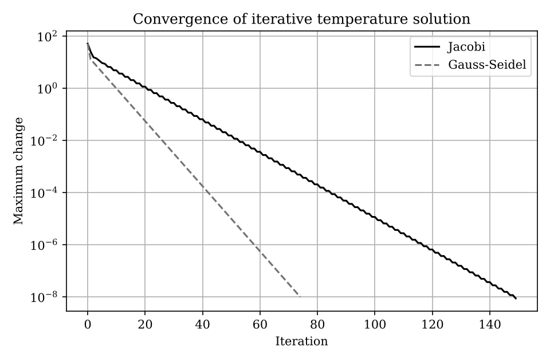
Note. Produced by Task_08_iterative_linear.py.
The vertical axis is logarithmic, so each curve is close to a straight line, which means the error shrinks by a constant factor every iteration. The Gauss-Seidel line is steeper and reaches 10⁻⁸ in half as many iterations as the Jacobi line. Both methods are converging, which is expected because the matrix is diagonally dominant.

Changing a Parameter
The tolerance was loosened from 1e-8 to 1e-3. The results are in Table 21.
Table 21
Iterations and Error for Two Tolerances
Tolerance | Jacobi iterations | Gauss-Seidel iterations | Jacobi max error | Gauss-Seidel max error
1e-8 | 150 | 75 | 3.41 × 10⁻⁸ | 2.89 × 10⁻⁸
1e-3 | 70 | 35 | 3.39 × 10⁻³ | 2.87 × 10⁻³

A looser tolerance halves the work, but the accuracy drops accordingly. Notice also that the true error at the 1e-3 setting (about 3 × 10⁻³) is larger than the tolerance itself. The stopping rule measures the change between iterations, and when convergence is slow the remaining error can be a few times bigger than that change.

Related Real-World Case: Steady-State Temperature Along a Metal Rod

Assumptions and Input Data
A thin rod is split into 8 interior points, with one end held at 80 °C and the other at 30 °C, and no heat lost along the sides. This produces the same tridiagonal structure as before, only larger. The temperatures are assumed. Table 22 summarizes the data.
Table 22
Input Data for the Related Case in Task 8
Item | Value or description
Interior points | 8
Boundary temperatures | 80 °C and 30 °C
Tolerance | 1e-8

Output and Interpretation
Gauss-Seidel temperatures: 74.444, 68.889, 63.333, 57.778, 52.222, 46.667, 41.111 and 35.556 °C, identical to the direct solution. Jacobi needed 326 iterations and Gauss-Seidel 166.
The plot for this case is Figure 2. Both lines are again almost straight on the logarithmic scale, but their slopes are gentler than in Figure 1, which is the visual form of the higher iteration counts.
Figure 2
Convergence for the Eight-Point Rod Model
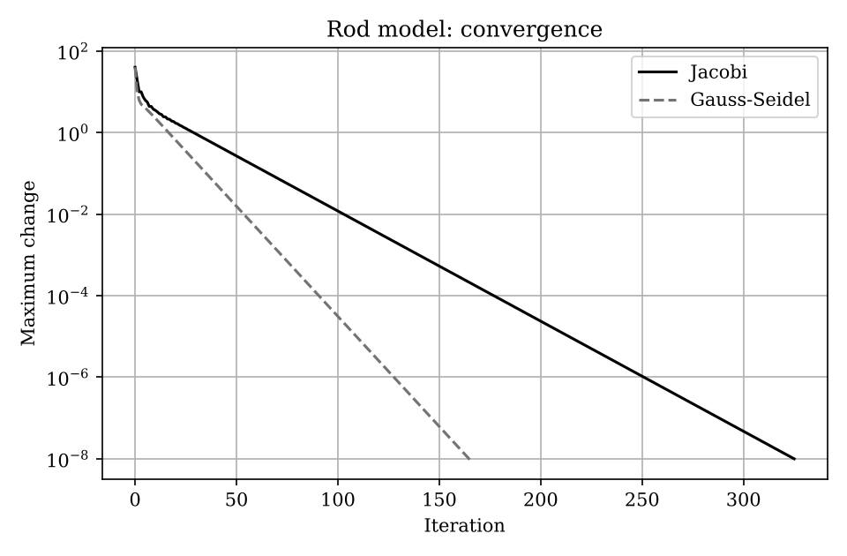
Note. Produced by Task_08_modified.py.
The profile drops by 5.556 °C per step, a straight line between the two ends, as theory predicts. Going from 5 to 8 unknowns roughly doubled the iteration counts (150 to 326, 75 to 166), so the cost of iterative methods grows with grid size. For very large sparse systems this is still cheaper than a direct factorization.

Task 9: Eigenvalues and Eigenvectors

Inputs and Mathematical Operation
The program is in the file Task_09_eigenvalues.py. Table 23 lists its inputs.
Table 23
Inputs Used in the Task 9 Program
Input | Value or description
A | 4 × 4 adjacency matrix: links A–B, A–C, B–C, B–D and C–D
Operation | Eigen-decomposition with np.linalg.eig(), then normalization of the dominant eigenvector

The program finds all eigenvalues and eigenvectors of the adjacency matrix and picks the largest eigenvalue. The matching eigenvector, taken in absolute value and divided by its sum, gives a score for each node. The final line checks that Av = λv.

Program Output
Running the program prints the following.
Dominant eigenvalue: 2.561552812808829
Eigenvector-based importance:
A: 0.2192
B: 0.2808
C: 0.2808
D: 0.2192
Verification error: 1.5059797815742444e-15

Meaning of the Output
The dominant eigenvalue is 2.5616, which equals (1 + √17)/2. Nodes B and C score 0.2808 each, and nodes A and D score 0.2192 each. B and C each connect to three other nodes while A and D connect to two, so they are structurally more influential. The verification error of about 10⁻¹⁵ confirms the computation.

Changing a Parameter
The missing A–D link was added, which makes every node connected to every other node. The results are in Table 24.
Table 24
Node Importance Before and After Adding a Link
Network | Dominant eigenvalue | Scores (A, B, C, D)
Original | 2.5616 | 0.2192, 0.2808, 0.2808, 0.2192
With A–D link | 3.0000 | 0.25, 0.25, 0.25, 0.25

Once all nodes have the same three connections, no node is more important than another and each scores 0.25. The eigenvalue rises to 3, which equals the number of links per node. Adding a single link therefore changed both the strength of the network and the ranking of its nodes.

Related Real-World Case: Identifying the Critical Device in a Campus Wi-Fi Network

Assumptions and Input Data
A small campus network has one core switch connected to four access points. The access points are also paired by direct links (AP1 with AP2, AP3 with AP4). Links are treated as undirected and equally weighted. The layout is assumed for the exercise. Table 25 summarizes the data.
Table 25
Input Data for the Related Case in Task 9
Item | Value or description
Nodes | Core, AP1, AP2, AP3, AP4
Links | Core to each AP; AP1–AP2; AP3–AP4

Output and Interpretation
Dominant eigenvalue 2.5616. Importance scores: Core 0.2808, and 0.1798 for each of AP1 to AP4.
The core switch carries about 28% of the total score and each access point about 18%, so the core is the most critical device. Its loss would disconnect the most traffic, which is useful when deciding where to add redundancy. All four access points score the same because they sit in identical positions.

Task 10: Root Finding: Bisection and Fixed-Point Methods

Inputs and Mathematical Operation
The program is in the file Task_10_bisection_fixed_point.py. Table 26 lists its inputs.
Table 26
Inputs Used in the Task 10 Program
Input | Value or description
f(T) | T − 25 − 10e^(−T/20), the heat-balance function
Bisection | Bracket [20, 40], tolerance 1e-10
Fixed point | T = g(T) = 25 + 10e^(−T/20), starting at T = 30

Bisection halves a bracket where f changes sign (f(20) = −8.68 and f(40) = 13.65) until it is tight enough. Fixed-point iteration rewrites f(T) = 0 as T = g(T) and repeats T ← g(T) until successive values agree to 1e-10.

Program Output
Running the program prints the following.
Bisection equilibrium temperature: 27.525211 C
Fixed-point equilibrium temperature: 27.525211 C
Bisection iterations: 38
Fixed-point iterations: 13

Meaning of the Output
Both methods give 27.525211 °C as the temperature at which heat gain equals heat loss. Bisection needed 38 iterations and fixed-point iteration only 13. The plot is shown in Figure 3.
Figure 3
Heat-Balance Function and Its Root
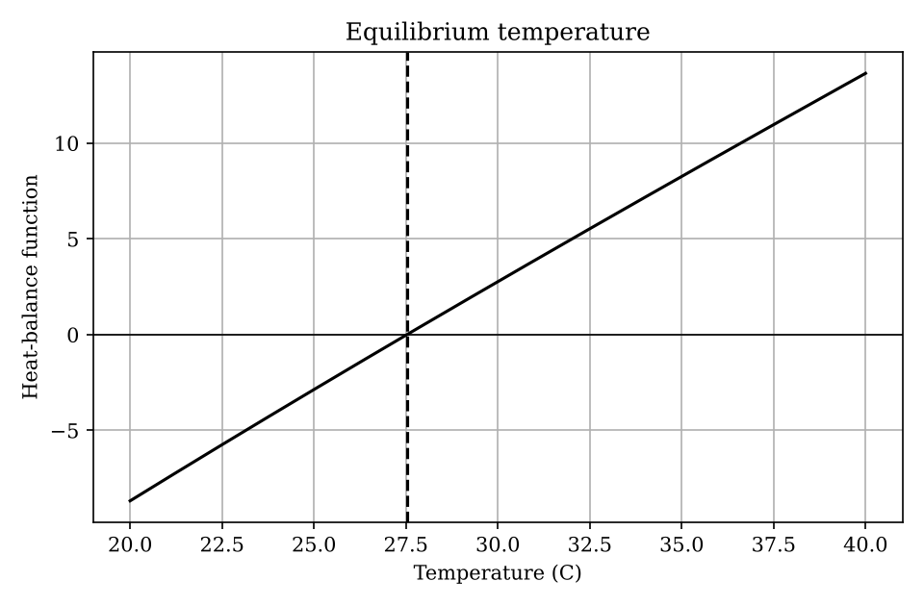
Note. Produced by Task_10_bisection_fixed_point.py.
The curve rises steadily from a negative value at 20 °C to a positive value at 40 °C and crosses zero once. The dashed vertical line marks that crossing at 27.5 °C. Because the curve crosses the axis only once in this range, the equilibrium is unique here.

Changing a Parameter
The heat-gain coefficient was increased from 10 to 40 (a bracket of [20, 60] was used so that the sign change stays inside it). The results are in Table 27.
Table 27
Effect of the Heat-Gain Coefficient on the Root and on Convergence
Coefficient | Root (°C) | Bisection it. | Fixed-point it. | |g′(root)|
10 | 27.525211 | 39 | 13 | 0.126
40 | 32.770612 | 39 | 27 | 0.389

A bigger heat gain pushes the equilibrium up by more than 5 °C. Bisection takes the same number of steps either way, because that count depends only on the bracket width and tolerance. Fixed-point iteration slows down, from 13 to 27 iterations, because it converges at a rate set by |g′| at the root, and that slope grew from 0.126 to 0.389. It still converges because the slope stays below 1. The 39 bisection steps for the original coefficient come from the wider [20, 60] bracket; the first run used [20, 40] and needed 38.

Related Real-World Case: Break-Even Quantity for a Small Bakery

Assumptions and Input Data
A bakery earns KES 450 per unit sold. Its cost is a fixed KES 60,000 plus KES 120 per unit plus an overtime term of 0.002q² for large volumes. Profit is revenue minus cost, and break-even is where profit is zero. All figures are assumed. Table 28 summarizes the data.
Table 28
Input Data for the Related Case in Task 10
Item | Value or description
Profit function | 450q − (60,000 + 120q + 0.002q²)
Brackets | [1, 400] for the first root and [1,000, 200,000] for the second

Output and Interpretation
First break-even at 182.02 units (29 bisection steps). Second root at 164,818 units. Profit at 100,000 units is KES 12,940,000.
The bakery must sell about 183 units to start making a profit. The second root is the volume at which the overtime term cancels the margin again; it is mathematically valid but far beyond what any bakery could produce, so in practice the model should be trusted only well below it. Quadratic equations give two roots, and each needs its own bracket.

Task 11: Root Finding: Newton-Raphson and Secant Methods

Inputs and Mathematical Operation
The program is in the file Task_11_newton_secant.py. Table 29 lists its inputs.
Table 29
Inputs Used in the Task 11 Program
Input | Value or description
cash_flows | [−10,000, 3,000, 3,500, 4,000, 2,500]: an investment followed by four annual inflows
Newton | Starting guess 0.10, using the derivative of NPV
Secant | Two starting guesses, 0.05 and 0.20, with no derivative

The net present value NPV(r) is the sum of each cash flow divided by (1 + r)ᵗ. The internal rate of return is the rate r at which NPV(r) = 0. The program finds this root with Newton-Raphson, which needs the derivative, and with the secant method, which only needs function values.

Program Output
Running the program prints the following.
IRR using Newton-Raphson: 11.542461%
IRR using Secant method: 11.542461%
NPV at Newton solution: 0.000000
Newton iterations: 4
Secant iterations: 7

Meaning of the Output
Both methods give an IRR of 11.542461%, and NPV at that rate is zero, so the answer is consistent. Newton converged in 4 iterations and the secant method in 7, which shows the faster convergence of Newton when a derivative is available. The project earns about 11.5% a year on the money invested, so it is worthwhile only if the cost of capital is lower than that.

Changing a Parameter
The initial investment was reduced from 10,000 to 9,000, with the inflows unchanged. The results are in Table 30.
Table 30
IRR for Two Initial Investments
Investment | IRR | Newton iterations
10,000 | 11.5425% | 4
9,000 | 16.7302% | 5

Paying less for the same inflows raises the return from 11.5% to 16.7%. The solver needed one more iteration, which is a small difference, but it shows that the cost of finding the root depends on the function being solved.

Related Real-World Case: Finding the True Interest Rate on a Loan

Assumptions and Input Data
A borrower receives KES 100,000 and repays KES 9,500 at the end of each month for 12 months, with no extra fees. We want the monthly rate that makes the present value of the repayments equal the amount borrowed. The loan figures are assumed. Table 31 summarizes the data.
Table 31
Input Data for the Related Case in Task 11
Item | Value or description
Cash flows | +100,000 now, then −9,500 for 12 months
Starting guesses | 0.02 (Newton); 0.01 and 0.03 (secant)

Output and Interpretation
Monthly rate 2.075742% from both methods. Nominal annual rate 24.9089%, effective annual rate 27.9589%. Total repaid KES 114,000, so interest paid is KES 14,000.
The loan may be advertised as 14% interest because KES 14,000 is paid on KES 100,000. The true cost is much higher, about 28% a year, because the borrower repays the principal gradually and so uses less than KES 100,000 on average. Root finding is what reveals this hidden rate.

Task 12: Polynomial and Nonlinear Equation Solving

Inputs and Mathematical Operation
The program is in the file Task_12_nonlinear_equations.py. Table 32 lists its inputs.
Table 32
Inputs Used in the Task 12 Program
Input | Value or description
Circle | x² + y² = 4
Parabola | y = x² − 1
Initial guesses | (1, 1) and (−1, 1)

The two equations are rewritten as residuals that should equal zero. scipy.optimize.root() then searches for the (x, y) that makes both residuals vanish, starting from each guess. Using two starting points helps find both intersections.

Program Output
Running the program prints the following.
Initial guess: [1.0, 1.0]
Intersection: [1.51748991 1.30277564]
Residuals: [np.float64(-2.4780177909633494e-13), np.float64(-2.4158453015843406e-13)]
Converged: True

Initial guess: [-1.0, 1.0]
Intersection: [-1.51748991 1.30277564]
Residuals: [np.float64(-2.4780177909633494e-13), np.float64(-2.4158453015843406e-13)]
Converged: True

Meaning of the Output
The guess (1, 1) leads to (1.5175, 1.3028) and the guess (−1, 1) leads to (−1.5175, 1.3028). The residuals are about 10⁻¹³ and the solver reports convergence. The result is symmetric because both curves are symmetric about the y-axis. It can be checked by algebra: substituting x² = y + 1 gives y² + y − 3 = 0, whose positive-x solution is y = (−1 + √13)/2 = 1.3028.

Changing a Parameter
The circle radius was increased from 2 to 3 (x² + y² = 9) with the same parabola. The results are in Table 33.
Table 33
Intersections for Two Circle Radii
Radius | Intersection points
2 | (±1.5175, 1.3028)
3 | (±1.8364, 2.3723)

A larger circle reaches the parabola further out and higher up. The algebra agrees: y² + y − 8 = 0 gives y = (−1 + √33)/2 = 2.3723. Residuals were zero to the printed precision.

Related Real-World Case: Cell-Tower Coverage Along a Curved Road

Assumptions and Input Data
A tower sits at (2, 1) with a coverage radius of 5 km. A road follows the curve y = 0.05x² + 0.2x − 3, with coordinates in kilometres. We want the points where the road enters and leaves the coverage circle. The tower and road are assumed. Table 34 summarizes the data.
Table 34
Input Data for the Related Case in Task 12
Item | Value or description
Coverage circle | (x − 2)² + (y − 1)² = 25
Road | y = 0.05x² + 0.2x − 3
Guesses | (6, 0), (−5, 0) and (0, −3)

Output and Interpretation
Two distinct intersections were found: (6.9977, 0.8479) and (−0.8181, −3.1302). The second guess and the third both converged to the second point. All residuals were below 10⁻¹⁰.
The road enters the coverage area near (−0.82, −3.13) and leaves near (7.00, 0.85). Between those points it is within range of the tower. A separate check of the underlying quartic polynomial showed exactly two real roots, so no other crossing was missed. In general several guesses should be tried, since different starting points can land on the same answer.

Task 13: Interpolation

Inputs and Mathematical Operation
The program is in the file Task_13_interpolation.py. Table 35 lists its inputs.
Table 35
Inputs Used in the Task 13 Program
Input | Value or description
hours | 8, 9, 10, 11, 12, 13, 14
temperature | 18.0, 20.0, 22.5, 24.0, 25.0, 25.5, 25.0 °C
Target | Estimates every 10 minutes and, specifically, at 10:30

interp1d(kind='linear') joins neighbouring points with straight lines. CubicSpline fits a smooth cubic between points so that the curve has continuous slope and curvature. Both are evaluated at ten-minute intervals.

Program Output
Running the program prints the following.
Linear estimate at 10:30: 23.25 C
Cubic estimate at 10:30: 23.36 C

Meaning of the Output
At 10:30 the linear estimate is 23.25 °C, exactly midway between 22.5 and 24.0. The cubic spline gives 23.36 °C, slightly higher because it follows the bend of the data. The plot is shown in Figure 4.
Figure 4
Linear and Cubic-Spline Interpolation of Hourly Temperatures
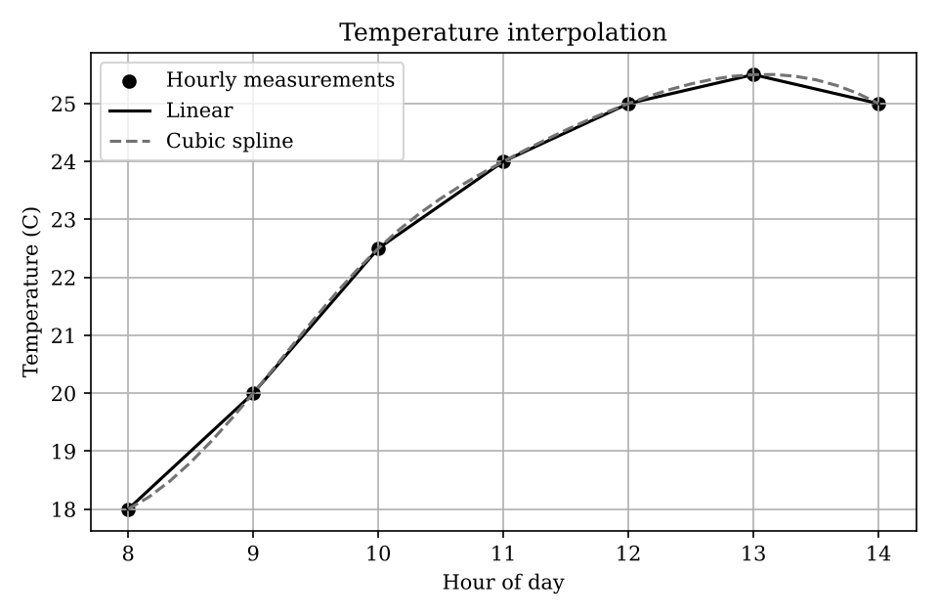
Note. Produced by Task_13_interpolation.py.
The dots are the hourly measurements, and both curves pass through every one of them. The linear line has visible corners at each hour, while the spline is smooth and rounds off the peak between 13:00 and 14:00. The two differ most where the data bends sharply, early in the morning and near the peak.

Changing a Parameter
The 11:00 reading (24.0 °C) was treated as missing, and both methods were asked to estimate it from the remaining points. The results are in Table 36.
Table 36
Recovering a Missing Reading
Method | Estimate at 11:00 (°C) | Error (°C)
Linear | 23.75 | 0.25
Cubic spline | 24.11 | 0.11

The spline is closer to the true value. The temperature curve is bending downward (concave), so a straight line between 10:00 and 12:00 sits below the curve, while the spline follows the curvature. The spline is not perfect, since it overshoots by 0.11 °C, but it is better here.

Related Real-World Case: Calibration Table for a Temperature Sensor

Assumptions and Input Data
A sensor outputs a raw ADC reading from 0 to 1023, and a lab supplies a six-point calibration table. We interpolate to convert any raw reading into degrees Celsius. The table values are invented. Table 37 summarizes the data.
Table 37
Input Data for the Related Case in Task 13
Item | Value or description
ADC values | 0, 200, 400, 600, 800, 1023
Temperatures (°C) | −10, 8, 26, 45, 66, 90
Queries | ADC 100, 500, 950 and 1100

Output and Interpretation
ADC 100: −1.00 °C (linear) and −0.95 °C (cubic). ADC 500: 35.50 and 35.28 °C. ADC 950: 82.14 and 82.24 °C. ADC 1100 raised a ValueError because it lies outside the table.
The two methods agree within about 0.2 °C, so for this table the simple linear method is adequate. The error for ADC 1100 is a feature, not a fault. Interpolation is only valid inside the measured range, and refusing to guess outside it prevents the system from reporting a confident but unsupported temperature.

Task 14: Curve Fitting and Approximation

Inputs and Mathematical Operation
The program is in the file Task_14_curve_fitting.py. Table 38 lists its inputs.
Table 38
Inputs Used in the Task 14 Program
Input | Value or description
users | 50, 100, 150, 200, 250, 300, 350 concurrent users
response_ms | 82, 95, 115, 145, 185, 238, 305 ms
Model | Quadratic y = ax² + bx + c, fitted by least squares with curve_fit

curve_fit chooses a, b and c to minimize the sum of squared differences between the model and the measurements. The program then reports the root-mean-square error (RMSE) and predicts the response time at 400 users, beyond the measured range.

Program Output
Running the program prints the following.
Fitted model: y = 0.002167x^2 + -0.1345x + 85.00
RMSE: 1.55 ms
Predicted response at 400 users: 377.86 ms

Meaning of the Output
The fitted curve is y = 0.002167x² − 0.1345x + 85.00 with an RMSE of 1.55 ms, so predictions are typically within about 1.5 ms of the measurements. At 400 users the model predicts 377.86 ms. The constant 85 ms is roughly the baseline delay, and the positive x² coefficient means delay grows faster as load increases. The negative x term is not a problem: the parabola's lowest point is near 31 users, outside the data. The plot is shown in Figure 5.
Figure 5
Quadratic Fit of Server Response Time Against Load
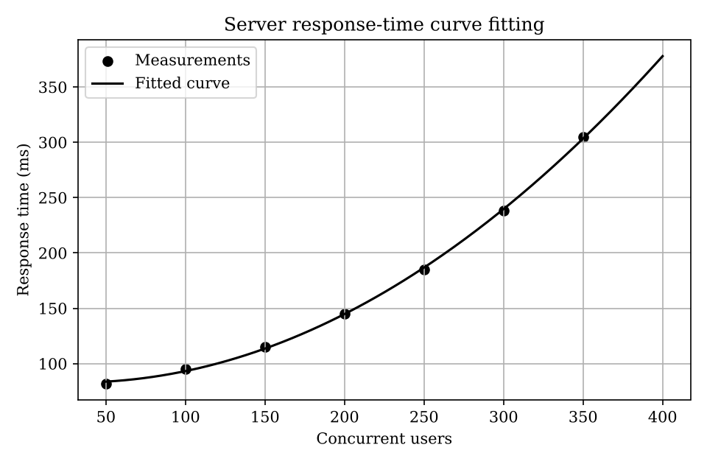
Note. Produced by Task_14_curve_fitting.py.
The measured points lie almost on the fitted curve. The curve is nearly flat at low load and then bends upward, which says that the server copes well until about 200 users and degrades quickly after that.

Changing a Parameter
The quadratic model was replaced with a straight line y = mx + c. The results are in Table 39.
Table 39
Quadratic Versus Linear Model
Model | RMSE (ms) | Prediction at 400 users (ms)
Quadratic | 1.55 | 377.9
Linear | 18.83 | 312.9

The line fits much worse (RMSE of 18.83 ms against 1.55 ms) because it cannot bend with the data. Its forecast at 400 users is about 65 ms lower than the quadratic forecast, so the linear model would give a misleadingly optimistic picture of performance under heavy load. The choice of model matters as much as the fitting itself.

Related Real-World Case: Growth Curve of a Maize Crop

Assumptions and Input Data
A farmer measures maize height weekly for ten weeks. Plant growth tends to be slow at first, fastest in the middle, and then to level off, so a logistic curve L/(1 + e^(−k(t − t₀))) is used. The heights are illustrative and not field data. Table 40 summarizes the data.
Table 40
Input Data for the Related Case in Task 14
Item | Value or description
Weeks | 1 to 10
Height (cm) | 8, 15, 26, 42, 65, 92, 118, 140, 155, 163
Starting guesses | L = 170, k = 0.6, t₀ = 6

Output and Interpretation
Fitted L = 176.0 cm, k = 0.623 per week and t₀ = 5.85 weeks. RMSE is 0.42 cm and R² is 0.9999. Predicted height at week 12 is 172.3 cm. Standard errors are 0.754, 0.005 and 0.021.
The plot for this case is Figure 6. The S-shaped curve passes through the points. It is steepest in the middle and flattens at both ends, and its extension to week 12 shows the plateau near 172 to 176 cm.
Figure 6
Logistic Growth Curve Fitted to Maize Heights
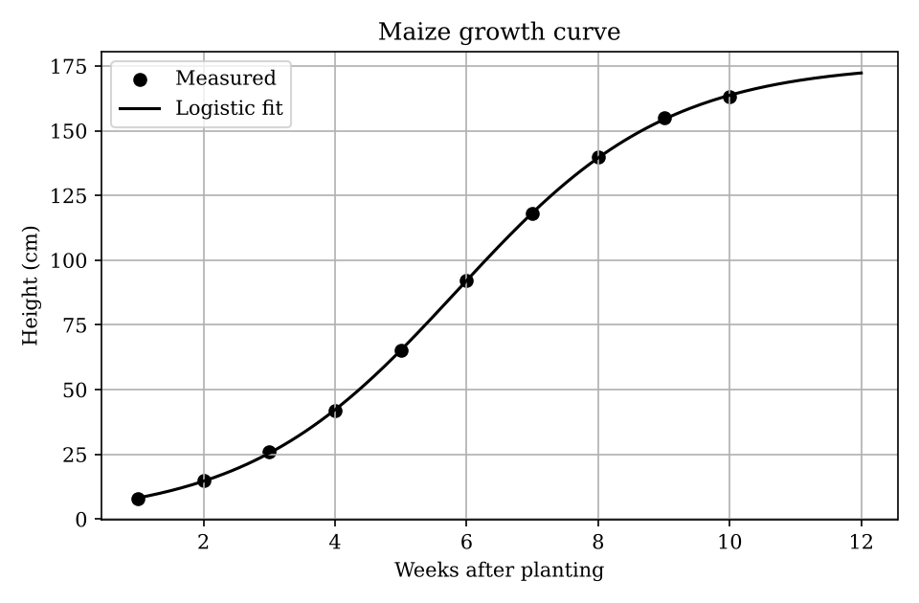
Note. Produced by Task_14_modified.py.
The crop is expected to level off near 176 cm, and its fastest growth is around week 6. The small standard errors and the very high R² show a close fit, though with only ten points and three parameters this should be treated with some caution. The forecast for week 12 is an extrapolation and is trustworthy only if conditions stay the same.

Task 15: Numerical Differentiation

Inputs and Mathematical Operation
The program is in the file Task_15_numerical_differentiation.py. Table 41 lists its inputs.
Table 41
Inputs Used in the Task 15 Program
Input | Value or description
time | 0, 1, 2, 3, 4, 5, 6 s
position | 0.0, 4.8, 10.2, 16.1, 22.7, 30.0, 38.0 m

Speed is the derivative of position. The program uses a forward difference at the first point, central differences at interior points, (xᵢ₊₁ − xᵢ₋₁)/(tᵢ₊₁ − tᵢ₋₁), and a backward difference at the last point.

Program Output
Running the program prints the following.
t=0s, position=0.0m, estimated speed=4.80m/s
t=1s, position=4.8m, estimated speed=5.10m/s
t=2s, position=10.2m, estimated speed=5.65m/s
t=3s, position=16.1m, estimated speed=6.25m/s
t=4s, position=22.7m, estimated speed=6.95m/s
t=5s, position=30.0m, estimated speed=7.65m/s
t=6s, position=38.0m, estimated speed=8.00m/s

Meaning of the Output
The estimated speeds are 4.80, 5.10, 5.65, 6.25, 6.95, 7.65 and 8.00 m/s. The vehicle is moving at about 17 to 29 km/h and speeding up. The end values rely on only one neighbour and are therefore less reliable than the interior ones. The plot is shown in Figure 7.
Figure 7
Speed Estimated From GPS Position Samples
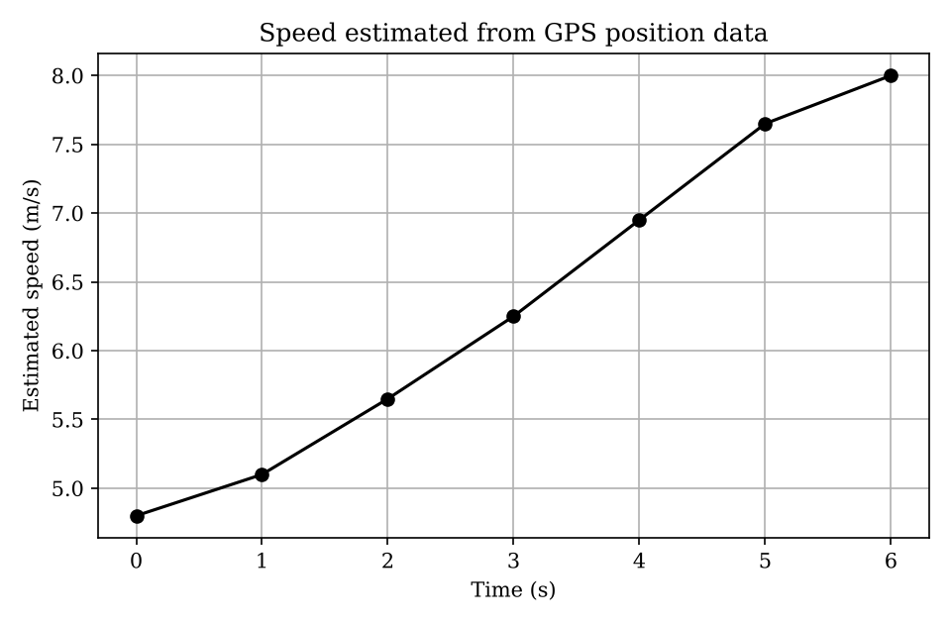
Note. Produced by Task_15_numerical_differentiation.py.
The line climbs steadily, so the vehicle accelerates throughout the six seconds. The slope of the line is the acceleration: about 0.3 m/s² at the start, rising to about 0.7 m/s² in the middle, and easing at the last step.

Changing a Parameter
A GPS glitch was simulated by changing the position at t = 3 s from 16.1 m to 19.1 m. The results are in Table 42.
Table 42
Speed Estimates With and Without a GPS Error
Time (s) | Original speed (m/s) | Glitched speed (m/s)
1 | 5.10 | 5.10
2 | 5.65 | 7.15
3 | 6.25 | 6.25
4 | 6.95 | 5.45
5 | 7.65 | 7.65

A 3 m error produced swings of 1.5 m/s, but not at the faulty point itself. A central difference at time t does not use the position at t, so the error shows up at t = 2 and t = 4 instead. Differentiation magnifies noise because it divides small differences by a small time step. A second test on f(x) = sin(x) at x = 1 showed the trade-off in step size: the central difference error fell from 9.0 × 10⁻⁴ at h = 0.1 to 9.0 × 10⁻¹⁰ at h = 10⁻⁴, but then round-off took over and the error grew to 1.2 × 10⁻⁵ at h = 10⁻¹².

Related Real-World Case: Acceleration of a Bus From a Speed Log

Assumptions and Input Data
A bus logs its speed every 5 seconds after leaving a stop: 0, 18, 31, 41, 48, 52 and 54 km/h. We convert to m/s and use np.gradient, which applies the same central and one-sided differences as above, to estimate acceleration. The speeds are assumed. Table 43 summarizes the data.
Table 43
Input Data for the Related Case in Task 15
Item | Value or description
Times (s) | 0, 5, 10, 15, 20, 25, 30
Speed (km/h) | 0, 18, 31, 41, 48, 52, 54

Output and Interpretation
Speeds in m/s: 0, 5.00, 8.61, 11.39, 13.33, 14.44, 15.00. Accelerations in m/s²: 1.00, 0.86, 0.64, 0.47, 0.31, 0.17, 0.11.
Acceleration is highest at the start and falls steadily as the bus nears its cruising speed of 54 km/h (15 m/s). That matches ordinary driving: strong acceleration from rest, then easing off. An acceleration of 1 m/s² is comfortable for passengers, so the data would not flag a harsh start.

Task 16: Numerical Integration

Inputs and Mathematical Operation
The program is in the file Task_16_numerical_integration.py. Table 44 lists its inputs.
Table 44
Inputs Used in the Task 16 Program
Input | Value or description
time_hours | 0, 2, 4, 6, 8, 10, 12 h
power_kw | 0.8, 1.0, 1.4, 1.8, 1.6, 1.2, 0.9 kW

Energy is the integral of power over time. The trapezoidal rule joins the readings with straight segments and adds up the areas. Simpson's rule fits parabolas through groups of three points, which is usually more accurate for smooth data.

Program Output
Running the program prints the following.
Energy using trapezoidal rule: 15.700 kWh
Energy using Simpson's rule: 15.800 kWh
Difference between estimates: 0.100 kWh

Meaning of the Output
Over the 12 hours the meter recorded about 15.7 kWh by the trapezoidal rule and 15.8 kWh by Simpson's rule, an average power of around 1.31 kW. The two estimates differ by only 0.1 kWh, which is under 1%, so the answer is not sensitive to the method here.

Changing a Parameter
The reading at 6 hours was raised from 1.8 kW to 2.4 kW to represent a higher evening peak. The results are in Table 45.
Table 45
Energy Estimates for Two Peak Values
Case | Trapezoid (kWh) | Simpson (kWh)
Original | 15.700 | 15.800
Peak at 2.4 kW | 16.900 | 17.400

A 0.6 kW rise at one reading adds 1.2 kWh under the trapezoidal rule (weight of 2 hours) but 1.6 kWh under Simpson's rule (weight of 8/3 hours), so the methods now differ by 0.5 kWh. This happens because Simpson's rule gives the middle point of each pair of intervals extra weight. A test on the integral of sin(x) from 0 to π, which equals 2, showed that doubling the number of points cut the trapezoid error by about four times (0.104 to 0.026 to 0.0064) and the Simpson error by about sixteen times (0.0046 to 0.00027 to 0.000017).

Related Real-World Case: Total Water Volume Passing a River Gauge

Assumptions and Input Data
A river gauge records discharge in cubic metres per second at the start of each hour for six hours: 12, 15, 24, 38, 41, 29 and 20 m³/s. Integrating discharge over time gives the total volume. The readings are assumed. Table 46 summarizes the data.
Table 46
Input Data for the Related Case in Task 16
Item | Value or description
Time (s) | 0 to 21,600 in steps of 3,600
Discharge (m³/s) | 12, 15, 24, 38, 41, 29, 20

Output and Interpretation
Trapezoid 586,800 m³. Simpson 588,000 m³. Difference 1,200 m³. Mean discharge 27.17 m³/s.
About 587,000 m³ of water passed the gauge in six hours. The two methods differ by 0.2%, so either is acceptable for planning. Using seconds as the time unit is essential: with hours the result would be off by a factor of 3,600.

Task 17: Ordinary Differential Equations: Euler Method

Inputs and Mathematical Operation
The program is in the file Task_17_euler_ode.py. Table 47 lists its inputs.
Table 47
Inputs Used in the Task 17 Program
Input | Value or description
T_ambient, T_initial | 25 °C and 90 °C
k | 0.12 per minute (cooling constant)
h, end_time | Step of 1 minute, running to 30 minutes

Newton's law of cooling is dT/dt = −k(T − T_ambient). Euler's method advances in small steps using Tₙ₊₁ = Tₙ + h · f(Tₙ). The program compares the result with the exact solution T = 25 + 65e^(−0.12t).

Program Output
Running the program prints the following.
Euler temperature after 30 min: 26.40 C
Exact temperature after 30 min: 26.78 C
Final absolute error: 0.3720 C

Meaning of the Output
After 30 minutes the Euler estimate is 26.40 °C and the exact temperature is 26.78 °C, an error of 0.372 °C. The object cools from 90 °C towards room temperature and almost reaches it. The plot is shown in Figure 8.
Figure 8
Euler Solution of Newton's Law of Cooling Compared With the Exact Curve
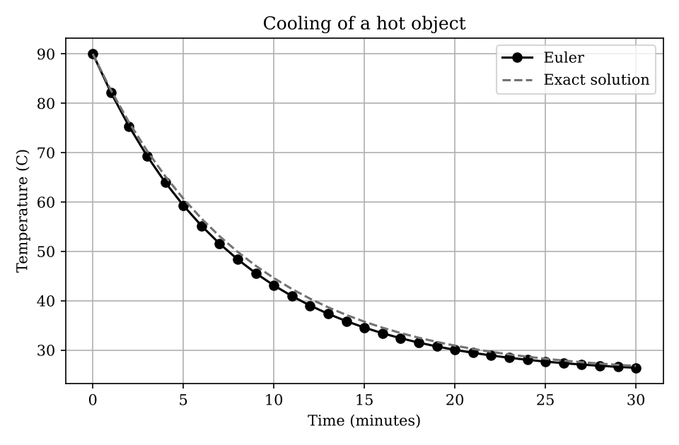
Note. Produced by Task_17_euler_ode.py.
The Euler points sit just under the exact curve all the way along. Euler cools slightly too quickly, because it multiplies the gap to room temperature by 0.88 each minute while the exact factor is e^(−0.12) = 0.887. Both curves fall steeply at first and then flatten as the object approaches 25 °C.

Changing a Parameter
The step size h was changed from 1 minute to 5 minutes and to 0.1 minutes. The results are in Table 48.
Table 48
Euler Accuracy for Different Step Sizes
Step size h (min) | Euler T(30) (°C) | Absolute error (°C)
5.0 | 25.266 | 1.5098
1.0 | 26.404 | 0.3720
0.1 | 26.738 | 0.0383

Smaller steps give smaller errors. Cutting h from 1 to 0.1 reduced the error from 0.372 to 0.038, almost exactly ten times, which is the signature of a first-order method (error proportional to h). The price is ten times more steps. With very large steps the method can also become unstable, and it would fail if kh exceeded 2.

Related Real-World Case: Growth of a Fish Population in a Pond

Assumptions and Input Data
A pond is stocked with 200 fish. Growth follows the logistic equation dP/dt = rP(1 − P/K) with r = 0.3 per month and a carrying capacity K of 5,000 fish. We step forward one month at a time with Euler's method and compare with the exact logistic solution. All values are assumed. Table 49 summarizes the data.
Table 49
Input Data for the Related Case in Task 17
Item | Value or description
P(0) | 200 fish
r, K | 0.3 per month, 5,000 fish
Step | 1 month, for 24 months

Output and Interpretation
Month 6: Euler 861.6, exact 1006.6. Month 12: 2679.8 and 3019.7. Month 18: 4445.3 and 4511.0. Month 24: 4924.5 and 4912.0.
The plot for this case is Figure 9. The h = 5 curve has only a few points and visibly cuts the corner, while the h = 0.1 curve is almost indistinguishable from the exact line.
Figure 9
Euler Cooling Curves for Three Step Sizes
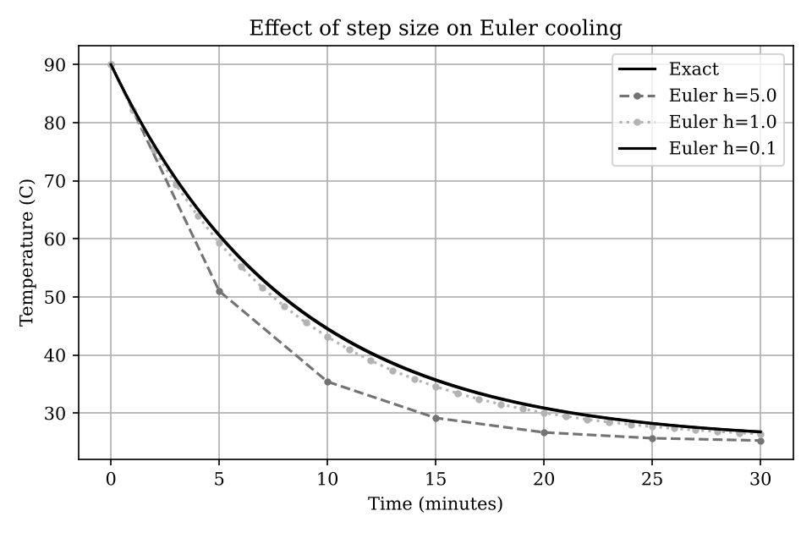
Note. Produced by Task_17_modified.py.
Euler runs behind the exact answer while the population is growing fast (a shortfall of 340 fish at month 12) and catches up as growth slows. At month 24 it slightly overshoots the exact value. For planning, one-month steps are rough, and a smaller step or a solver such as solve_ivp would be a better choice.

Task 18: Numerical Solution of ODEs Using SciPy

Inputs and Mathematical Operation
The program is in the file Task_18_scipy_ode.py. Table 50 lists its inputs.
Table 50
Inputs Used in the Task 18 Program
Input | Value or description
Vs, R, C | 5 V, 1000 Ω and 0.001 F
V0 | 0 V (uncharged capacitor)
Solver settings | Interval 0 to 5 s, relative tolerance 1e-9, absolute tolerance 1e-11

The circuit obeys dV/dt = (Vs − V)/(RC). solve_ivp integrates this equation with an adaptive Runge-Kutta method, choosing its own internal step sizes, and returns values at 200 requested times. The program compares them with the exact curve Vs(1 − e^(−t/RC)).

Program Output
Running the program prints the following.
Solver success: True
Capacitor voltage at 5 s: 4.9663 V
Maximum error against exact solution: 9.282e-10 V

Meaning of the Output
The solver reports success. The capacitor voltage at 5 s is 4.9663 V, which is 99.3% of the 5 V supply, and the largest difference from the exact solution is 9.3 × 10⁻¹⁰ V. The time constant RC is 1 s. The plot is shown in Figure 10.
Figure 10
RC Circuit Charging: solve_ivp Against the Exact Solution
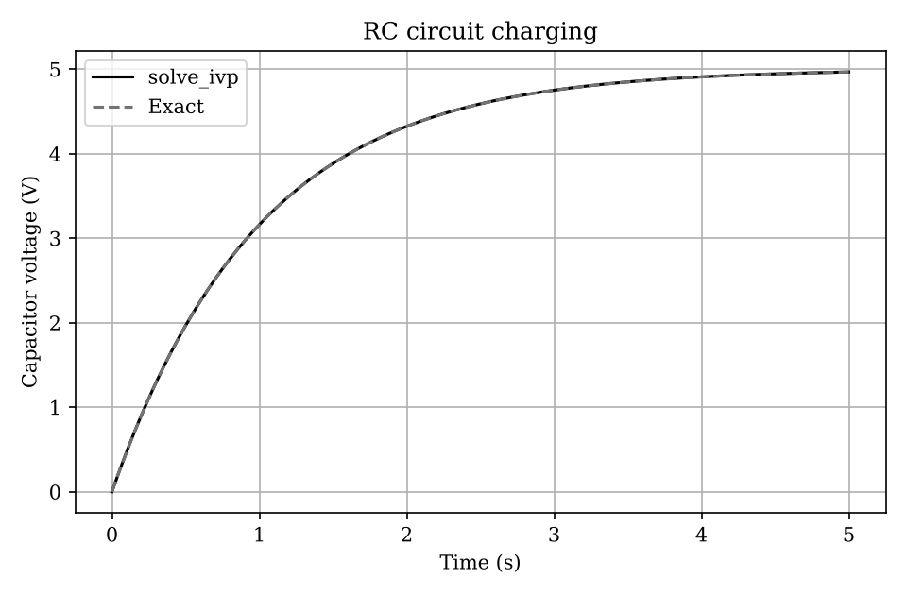
Note. Produced by Task_18_scipy_ode.py.
The voltage rises quickly at the start and then levels off toward 5 V, the classic charging curve. The dashed exact line lies on top of the solver line, so the two cannot be told apart at this scale.

Changing a Parameter
The resistance was doubled from 1000 Ω to 2000 Ω, which doubles the time constant from 1 s to 2 s. The results are in Table 51.
Table 51
RC Charging for Two Resistances
Resistance (Ω) | Time constant (s) | V at 5 s (V) | Time to reach 63.2% (s)
1000 | 1 | 4.9663 | about 1.0
2000 | 2 | 4.5896 | about 2.0

With the larger resistor the capacitor charges more slowly, so after 5 s it has reached only 4.59 V. The time to reach 63.2% of the supply voltage matches the time constant in each case, which is a useful check on the solver. Times are read from a grid with spacing of about 0.025 s, hence the word 'about'.

Related Real-World Case: Spread of an Epidemic Using the SIR Model

Assumptions and Input Data
A population of 10,000 people starts with 10 infected. The SIR model tracks susceptible (S), infected (I) and recovered (R) people with dS/dt = −βSI/N, dI/dt = βSI/N − γI and dR/dt = γI. We take β = 0.3 and γ = 0.1 per day, so the basic reproduction number is 3. The model assumes a well-mixed population, no vaccination and permanent immunity. Table 52 summarizes the data.
Table 52
Input Data for the Related Case in Task 18
Item | Value or description
N, I(0) | 10,000 people, 10 infected
β, γ | 0.3 and 0.1 per day
Interval | 0 to 160 days

Output and Interpretation
R₀ = 3.0. Infections peak at about 3,008 people on day 38. In the end 9,405 people (94.1%) have recovered. The total S + I + R stays at 10,000 to within 5.5 × 10⁻¹².
The plot for this case is Figure 11. The susceptible line falls steadily as people become infected. The infected line rises to a single peak around day 38 and then declines, and the recovered line rises in an S shape toward about 9,400.
Figure 11
SIR Epidemic Curves for a Population of 10,000
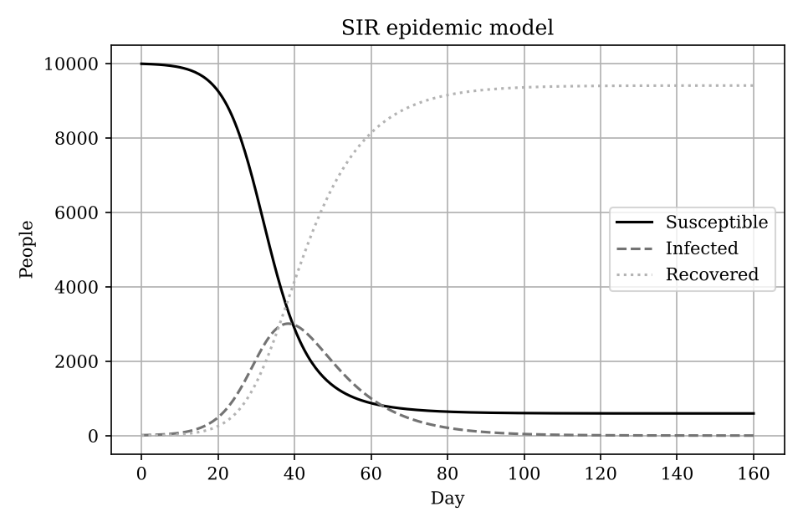
Note. Produced by Task_18_modified.py.
Because R₀ is well above 1, the outbreak reaches most of the population, and nearly 3,000 people are sick at the same moment. The conservation check is a quick test of correctness, since nobody should be created or lost. Lowering β, for example through distancing, would flatten and delay the peak.

Task 19: Numerical Optimization

Inputs and Mathematical Operation
The program is in the file Task_19_optimization.py. Table 53 lists its inputs.
Table 53
Inputs Used in the Task 19 Program
Input | Value or description
Objective | Minimize cost = 12x + 18y
Constraint | 100x + 170y ≥ 1000 (minimum capacity)
Bounds and start | x, y ≥ 0; starting point (5, 3); method SLSQP

minimize() searches for the cheapest allocation that satisfies the capacity requirement and the non-negativity bounds. Since real servers come in whole numbers, the program also checks nearby integer combinations and keeps the cheapest.

Program Output
Running the program prints the following.
Optimization success: True
Type A allocation: 0.000
Type B allocation: 5.882
Total capacity: 1000.00
Minimum planning cost: 105.88
Best nearby integer solution: (108, 0, 6, 1020)

Meaning of the Output
The optimizer allocates nothing to Type A and 5.882 units to Type B, exactly meeting the capacity of 1,000 at a cost of 105.88. Type B costs 18/170 = 0.106 per unit of capacity against 12/100 = 0.120 for Type A, so it is the better buy. With whole servers the best choice is 6 of Type B, costing 108 and giving 1,020 capacity.

Changing a Parameter
The cost of Type A was reduced from 12 to 8. The results are in Table 54.
Table 54
Optimal Allocation for Two Prices of Type A
Cost of Type A | Type A | Type B | Total cost
12 | 0.000 | 5.882 | 105.88
8 | 10.000 | 0.000 | 80.00

The answer flips completely from all Type B to all Type A. At a price of 8, Type A costs 0.08 per unit of capacity, which beats Type B at 0.106. Problems with straight-line costs and constraints have their optimum at a corner, so a small price change can move the solution from one corner to another.

Related Real-World Case: Choosing a Matatu Fleet to Carry 400 Passengers per Hour

Assumptions and Input Data
A route needs to move at least 400 passengers per hour. A 14-seater costs KES 3,000 per trip and a 33-seater costs KES 6,500 per trip, and every vehicle is assumed to make one full trip per hour. The prices are invented, and vehicles must be whole numbers. Table 55 summarizes the data.
Table 55
Input Data for the Related Case in Task 19
Item | Value or description
Costs (KES) | 3,000 and 6,500
Seats | 14 and 33
Requirement | At least 400 seats per hour

Output and Interpretation
Continuous optimum: 0 small and 12.121 large vehicles at KES 78,787. Best whole-vehicle plan: 5 small and 10 large vehicles, cost KES 80,000 with exactly 400 seats. Cost per seat: KES 214.3 (small) and 197.0 (large).
The large vehicle is cheaper per seat, so the continuous answer uses only large ones. A fleet cannot contain 12.12 vehicles. Rounding up to 13 large vehicles would cost KES 84,500, while the integer search finds a mixed fleet at KES 80,000. Rounding a continuous answer is not always the best whole-number choice.

Task 20: Random Numbers and Monte Carlo Methods

Inputs and Mathematical Operation
The program is in the file Task_20_monte_carlo.py. Table 56 lists its inputs.
Table 56
Inputs Used in the Task 20 Program
Input | Value or description
capacity | 1,000 requests
Demand | Normal distribution with mean 850 and standard deviation 120
N, seed | 100,000 simulations, seed 42

The program draws 100,000 random demand values, marks those above capacity as overloads and takes the proportion of overloads as the estimated probability. It also tracks the running estimate as more simulations are added.

Program Output
Running the program prints the following.
Estimated overload probability: 10.6160%
Number of overload cases: 10616 out of 100000

Meaning of the Output
The estimated probability that demand exceeds capacity is 10.62%, from 10,616 overloads in 100,000 trials. The exact value for this distribution is 10.57%, so the simulation is within 0.05 percentage points. In plain terms, the server would be overloaded in roughly one period out of ten. The plot is shown in Figure 12.
Figure 12
Convergence of the Monte Carlo Overload Estimate
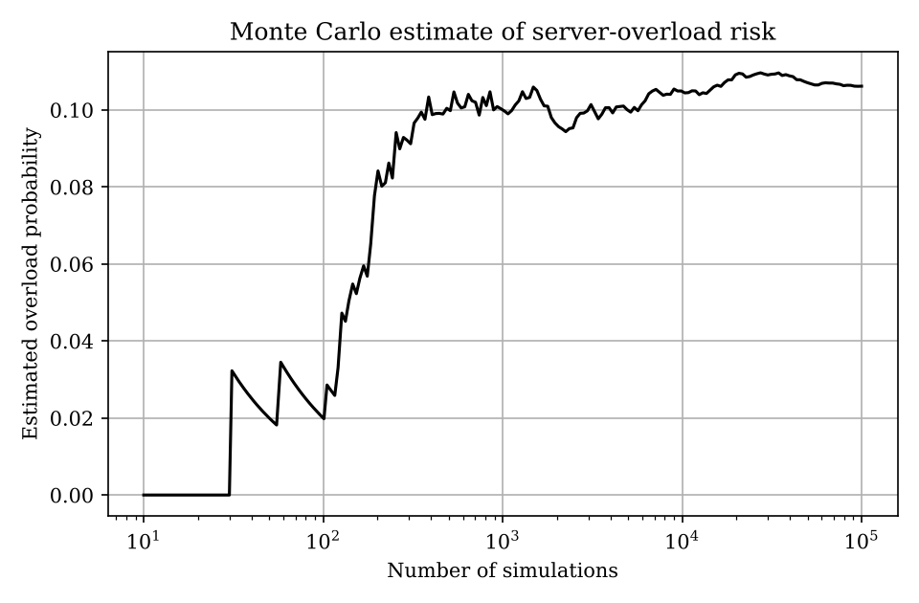
Note. Produced by Task_20_monte_carlo.py.
With only a few simulations the estimate is wildly unstable: it starts at zero because no overload has been seen yet, then jumps around. By about 1,000 simulations it is near 0.10 and by 10,000 or more the line is almost flat close to 0.106. This is the law of large numbers at work.

Changing a Parameter
Capacity was raised to 1,100, and separately the number of simulations was reduced to 1,000 using three different random seeds. The results are in Table 57.
Table 57
Monte Carlo Estimates for Different Capacities and Sample Sizes
Capacity | N | Seed | Estimate | Exact value
1,000 | 100,000 | 42 | 10.616% | 10.565%
1,100 | 100,000 | 42 | 1.912% | 1.861%
1,000 | 1,000 | 42 | 10.100% | 10.565%
1,000 | 1,000 | 7 | 8.100% | 10.565%
1,000 | 1,000 | 99 | 10.600% | 10.565%

Extra capacity of 100 requests cuts the overload risk from about 10.6% to about 1.9%, which shows how much safety a modest upgrade buys. With only 1,000 simulations the answer depends noticeably on the seed (8.1% to 10.6%), while 100,000 simulations are stable. The typical error shrinks with the square root of the number of simulations, so about 0.97 percentage points for N = 1,000 and 0.10 for N = 100,000.

Related Real-World Case: Will a Three-Stage Software Project Finish Within 30 Days?

Assumptions and Input Data
A project has three sequential stages, each with uncertain duration described by a triangular distribution (minimum, most likely, maximum): design (5, 8, 14 days), build (10, 14, 25 days) and testing (3, 5, 10 days). Stages are assumed independent. We run 200,000 simulations. The estimates are invented. Table 58 summarizes the data.
Table 58
Input Data for the Related Case in Task 20
Item | Value or description
Design | Triangular(5, 8, 14) days
Build | Triangular(10, 14, 25) days
Testing | Triangular(3, 5, 10) days
Simulations | 200,000, seed 42

Output and Interpretation
Mean total duration 31.33 days and 90th percentile 36.67 days. The probability of exceeding 30 days is 60.57% and of exceeding 35 days is 18.43%.
The plot for this case is Figure 13. The histogram is bell-shaped with a slightly longer tail on the late side. It peaks close to 30 days, and the dashed deadline line cuts it near the top, so a little over 60% of the distribution lies to its right. That is the visual form of the 60.57% chance of missing the deadline.
Figure 13
Distribution of Simulated Total Project Duration
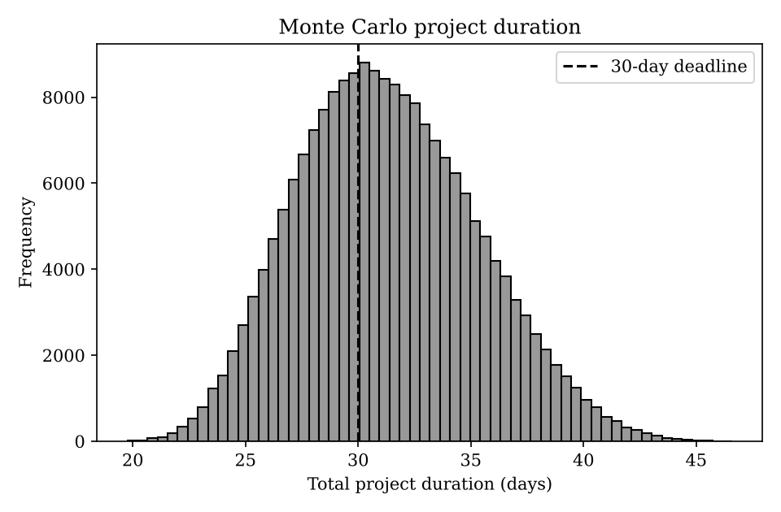
Note. Produced by Task_20_modified.py.
The most likely durations add up to 27 days, but the average is 31.3 days because each stage can run late by more than it can run early. A 30-day deadline has only about a 39% chance of being met. A manager would need to plan for roughly 37 days to be 90% confident, which a single-number estimate would not reveal.

References
Matplotlib Development Team. (n.d.). Matplotlib documentation. https://matplotlib.org/stable/
Mount Kenya University. (2026). BIT 2118: Scientific computing group work [Course brief].
NumPy Developers. (n.d.). NumPy documentation. https://numpy.org/doc/
SciPy Developers. (n.d.). SciPy documentation. https://docs.scipy.org/doc/scipy/

Appendix A

Modified Programs
Each file below holds the changed-parameter test followed by the related real-world case, in the order they are discussed in the report. The files need the same libraries as the original programs. In a normal run, plt.show() opens the plot window; for this report the plots were saved as images instead.

Task_02_modified.py
import numpy as np
print("--- PARAMETER CHANGE: one reading replaced by a 40 C spike ---")
t = np.array([18.5,18.0,17.8,17.5,17.9,19.0,21.5,23.8,25.6,27.1,28.3,29.0,
29.4,29.1,28.5,27.6,26.2,24.8,23.4,22.1,21.0,20.2,19.6,19.0])
t2 = t.copy(); t2[12] = 40.0
print(f"Original mean {t.mean():.2f} max {t.max():.2f}")
print(f"Changed mean {t2.mean():.2f} max {t2.max():.2f} median {np.median(t2):.2f}")
print("--- RELATED CASE: cold-storage sensor ---")
cs = np.array([3.2,3.5,3.9,4.4,5.1,6.0,7.2,8.6,9.1,7.4,5.8,4.6])
mean_c = cs.mean(); k = cs + 273.15
alarm = cs > 8.0
print(f"Mean {mean_c:.2f} C, min {cs.min():.1f}, max {cs.max():.1f}")
print("Readings above 8 C at positions:", np.where(alarm)[0] + 1, "->", cs[alarm])
print("Fraction above threshold:", f"{alarm.mean():.1%}")
print("First three in Kelvin:", k[:3])

Task_03_modified.py
import numpy as np, timeit
print("--- PARAMETER CHANGE: array size ---")
rng = np.random.default_rng(42)
for n in (100_000, 1_000_000, 3_000_000):
x = rng.uniform(5, 250, n)
def loop():
out=[]
for v in x:
s=v/1000.0; out.append(s**2)
return out
def vec():
return (x/1000.0)**2
lt = timeit.timeit(loop, number=1); vt = timeit.timeit(vec, number=3)/3
print(f"n={n:>9,} loop={lt:.4f}s vectorized={vt:.5f}s speed-up={lt/vt:.0f}x")
print("--- RELATED CASE: mobile-money fees on 1,000,000 transactions ---")
amounts = rng.uniform(50, 70_000, 1_000_000) # KES
def fee_loop():
out=[]
for a in amounts:
out.append(min(max(a*0.01, 5.0), 108.0))
return out
def fee_vec():
return np.clip(amounts*0.01, 5.0, 108.0)
lt = timeit.timeit(fee_loop, number=1); vt = timeit.timeit(fee_vec, number=3)/3
f = fee_vec()
print(f"Mean fee KES {f.mean():.2f}; total fees KES {f.sum():,.0f}; capped at 108: {(f==108).mean():.1%}")
print(f"loop={lt:.3f}s vectorized={vt:.4f}s speed-up={lt/vt:.0f}x")

Task_04_modified.py
import numpy as np, math
from decimal import Decimal
print("--- PARAMETER CHANGE: approximation 1.414 -> 1.4142 ---")
t = np.sqrt(2)
for a in (1.414, 1.4142, 1.41421356):
ae = abs(t-a); print(f"approx={a}: absolute={ae:.2e}, relative={ae/t:.4%}")
print("--- RELATED CASE: adding 0.10 KES one million times ---")
s = 0.0
for _ in range(1_000_000): s += 0.10
print(f"Naive float sum : {s:.10f}")
print(f"math.fsum : {math.fsum([0.10]*1_000_000):.10f}")
d = sum([Decimal('0.10')]*1_000_000)
print(f"Decimal sum : {d}")
print(f"Drift (naive-exact): {s-100000:.3e} KES")
print("Equal to 100000.0?", s == 100000.0, "| isclose?", np.isclose(s, 100000.0))

Task_05_modified.py
import numpy as np
def make(angle_deg, sx, sy):
a = np.deg2rad(angle_deg)
R = np.array([[np.cos(a), -np.sin(a)],[np.sin(a), np.cos(a)]])
S = np.diag([sx, sy]); return R @ S
sq = np.array([[0,0],[1,0],[1,1],[0,1]], float)
print("--- PARAMETER CHANGE: angle 45 -> 90 degrees (scale unchanged) ---")
T = make(90, 2.0, 1.5)
print(np.round(sq @ T.T, 4)); print("det =", round(np.linalg.det(T), 4))
print("--- RELATED CASE: drone survey path, rotate 30 deg and scale to map (0.5) ---")
path = np.array([[0,0],[40,0],[40,30],[0,30],[0,0]], float) # metres
T = make(30, 0.5, 0.5)
out = path @ T.T
print(np.round(out, 3)); print("det =", round(np.linalg.det(T), 4), "(area factor)")
side_before = np.linalg.norm(path[1]-path[0]); side_after = np.linalg.norm(out[1]-out[0])
print(f"First leg length: {side_before:.1f} -> {side_after:.1f}")

Task_06_modified.py
import numpy as np
print("--- PARAMETER CHANGE: observed memory 72 -> 80 GB ---")
A = np.array([[4.,2.],[8.,12.]])
for b in ([20.,72.],[20.,80.]):
x = np.linalg.solve(A, np.array(b)); print("b =", b, "-> x =", np.round(x,4))
print("--- RELATED CASE: mesh currents in a three-loop circuit ---")
# 10 V source in loop 1, 5 V in loop 3 (opposing); resistances in ohms
R = np.array([[ 30., -10., 0.],
[-10., 35., -15.],
[ 0., -15., 40.]])
V = np.array([10., 0., -5.])
I = np.linalg.solve(R, V)
print("Mesh currents (A):", np.round(I, 5))
print("Residual norm:", np.linalg.norm(V - R@I))
print("Condition number of R:", round(np.linalg.cond(R), 2))

Task_07_modified.py
import numpy as np, time
from scipy.linalg import lu_factor, lu_solve
print("--- PARAMETER CHANGE: diagonal 4 -> 6 (stronger coupling to ground) ---")
A1 = np.array([[4.,-1,0],[-1,4,-1],[0,-1,3]]); A2 = np.array([[6.,-1,0],[-1,6,-1],[0,-1,5]])
b = np.array([15.,10,10])
print("Original:", np.round(np.linalg.solve(A1,b),4)); print("Changed :", np.round(np.linalg.solve(A2,b),4))
print("--- RELATED CASE: 500 x 500 structural model, 2000 load vectors ---")
rng = np.random.default_rng(1); n=500
M = rng.random((n,n)) + n*np.eye(n)
loads = rng.random((n, 2000))
t0=time.perf_counter()
for j in range(2000): np.linalg.solve(M, loads[:,j])
t_repeat = time.perf_counter()-t0
t0=time.perf_counter(); lu,piv = lu_factor(M)
for j in range(2000): lu_solve((lu,piv), loads[:,j])
t_lu = time.perf_counter()-t0
x_ref = np.linalg.solve(M, loads[:,0]); x_lu = lu_solve((lu,piv), loads[:,0])
print(f"Re-solve every time: {t_repeat:.2f}s | LU once + reuse: {t_lu:.2f}s | ratio {t_repeat/t_lu:.1f}x")
print("Max difference between methods:", np.max(np.abs(x_ref-x_lu)))

Task_08_modified.py
import numpy as np, matplotlib.pyplot as plt
def jacobi(A,b,tol,mi=5000):
D=np.diag(A); R=A-np.diagflat(D); x=np.zeros_like(b); e=[]
for _ in range(mi):
xn=(b-R@x)/D; err=np.linalg.norm(xn-x,np.inf); e.append(err); x=xn
if err<tol: break
return x,e
def gs(A,b,tol,mi=5000):
x=np.zeros_like(b); e=[]
for _ in range(mi):
old=x.copy()
for i in range(len(b)):
x[i]=(b[i]-A[i,:i]@x[:i]-A[i,i+1:]@old[i+1:])/A[i,i]
err=np.linalg.norm(x-old,np.inf); e.append(err)
if err<tol: break
return x,e
def tri(n): return 2*np.eye(n)-np.eye(n,k=1)-np.eye(n,k=-1)
print("--- PARAMETER CHANGE: tolerance 1e-8 -> 1e-3 (5 grid points, 100 C / 20 C) ---")
A=tri(5); b=np.array([100.,0,0,0,20.]); ex=np.linalg.solve(A,b)
for tol in (1e-8,1e-3):
xj,ej=jacobi(A,b,tol); xg,eg=gs(A,b,tol)
print(f"tol={tol:g}: Jacobi {len(ej)} it, max error {np.max(abs(xj-ex)):.2e}; GS {len(eg)} it, max error {np.max(abs(xg-ex)):.2e}")
print("--- RELATED CASE: metal rod, 8 interior points, ends held at 80 C and 30 C ---")
n=8; A=tri(n); b=np.zeros(n); b[0]=80; b[-1]=30; ex=np.linalg.solve(A,b)
xj,ej=jacobi(A,b,1e-8); xg,eg=gs(A,b,1e-8)
print("Direct :", np.round(ex,3)); print("GS :", np.round(xg,3))
print(f"Iterations: Jacobi {len(ej)}, Gauss-Seidel {len(eg)}")
plt.semilogy(ej,label="Jacobi"); plt.semilogy(eg,label="Gauss-Seidel")
plt.xlabel("Iteration"); plt.ylabel("Maximum change"); plt.title("Rod model: convergence"); plt.legend(); plt.grid(True); plt.show()

Task_09_modified.py
import numpy as np
def cent(A):
w,v = np.linalg.eig(A); i=np.argmax(w.real); vec=np.abs(v[:,i].real); return w[i].real, vec/vec.sum()
print("--- PARAMETER CHANGE: add the missing A-D link (network becomes complete) ---")
A = np.array([[0,1,1,0],[1,0,1,1],[1,1,0,1],[0,1,1,0]],float)
lam,c = cent(A); print("Original:", round(lam,4), np.round(c,4))
A2 = A.copy(); A2[0,3]=A2[3,0]=1
lam,c = cent(A2); print("Changed :", round(lam,4), np.round(c,4))
print("--- RELATED CASE: campus Wi-Fi, one core switch (S) and four access points ---")
nodes = ["Core","AP1","AP2","AP3","AP4"]
W = np.array([[0,1,1,1,1],
[1,0,1,0,0],
[1,1,0,0,0],
[1,0,0,0,1],
[1,0,0,1,0]],float)
lam,c = cent(W)
print("Dominant eigenvalue:", round(lam,4))
for n_,s in zip(nodes,c): print(f"{n_}: {s:.4f}")

Task_10_modified.py
import numpy as np
from scipy.optimize import root_scalar
print("--- PARAMETER CHANGE: heat-gain coefficient 10 -> 40 ---")
for c in (10,40):
f=lambda T: T-25-c*np.exp(-T/20)
r=root_scalar(f,bracket=[20,60],method="bisect",xtol=1e-10)
g=lambda T: 25+c*np.exp(-T/20); T=30.0; n=0
for n in range(1,200):
Tn=g(T)
if abs(Tn-T)<1e-10: T=Tn; break
T=Tn
print(f"c={c}: bisection {r.root:.6f} C ({r.iterations} it) | fixed-point {T:.6f} C ({n} it) | |g'(root)|={c/20*np.exp(-r.root/20):.3f}")
print("--- RELATED CASE: bakery break-even quantity ---")
# Revenue 450 KES/loaf-box; cost = 60000 fixed + 120/unit + 0.002*q^2 (overtime)
def profit(q): return 450*q-(60000+120*q+0.002*q**2)
r=root_scalar(profit,bracket=[1,400],method="bisect",xtol=1e-6)
print(f"First break-even quantity: {r.root:.2f} units ({r.iterations} bisection steps)")
r2=root_scalar(profit,bracket=[1000,200000],method="bisect",xtol=1e-6)
print(f"Second break-even (overtime costs overtake revenue): {r2.root:.1f} units")
print(f"Profit at 100000 units: KES {profit(100000):,.0f}")

Task_11_modified.py
from scipy.optimize import root_scalar
def make(cf):
npv=lambda r: sum(c/(1+r)**t for t,c in enumerate(cf))
d=lambda r: sum(-t*c/(1+r)**(t+1) for t,c in enumerate(cf) if t>0)
return npv,d
print("--- PARAMETER CHANGE: initial investment 10000 -> 9000 ---")
for inv in (10000,9000):
npv,d=make([-inv,3000,3500,4000,2500])
r=root_scalar(npv,fprime=d,x0=0.1,method="newton",xtol=1e-12)
print(f"Investment {inv}: IRR = {r.root:.4%} ({r.iterations} Newton iterations)")
print("--- RELATED CASE: true interest rate on a loan ---")
# Receive 100,000 KES, repay 9,500 KES monthly for 12 months
cf=[100000]+[-9500]*12
npv,d=make(cf)
m=root_scalar(npv,fprime=d,x0=0.02,method="newton",xtol=1e-12)
s=root_scalar(npv,x0=0.01,x1=0.03,method="secant",xtol=1e-12)
print(f"Monthly rate (Newton): {m.root:.6%} | (Secant): {s.root:.6%}")
print(f"Nominal annual (x12): {12*m.root:.4%} | Effective annual: {(1+m.root)**12-1:.4%}")
print(f"Total repaid: {9500*12:,} KES -> interest paid {9500*12-100000:,} KES")

Task_12_modified.py
import numpy as np
from scipy.optimize import root
print("--- PARAMETER CHANGE: circle radius 2 -> 3 (x^2+y^2=9) with the same parabola ---")
def eq(r):
return lambda z: [z[0]**2+z[1]**2-r**2, z[1]-(z[0]**2-1)]
for guess in ([1.,1.],[-1.,1.]):
s=root(eq(3),guess); print("guess",guess,"->",np.round(s.x,5),"converged:",s.success,"res",np.round(eq(3)(s.x),10))
print("--- RELATED CASE: cell-tower coverage circle vs a curved road ---")
# Tower at (2,1), radius 5 km. Road: y = 0.05 x^2 + 0.2 x - 3
def eq2(z):
x,y=z; return [(x-2)**2+(y-1)**2-25, y-(0.05*x**2+0.2*x-3)]
for guess in ([6.,0.],[-5.,0.],[0.,-3.]):
s=root(eq2,guess); print("guess",guess,"->",np.round(s.x,4),"converged:",s.success,"max|res|:",f"{np.max(np.abs(eq2(s.x))):.1e}")

Task_13_modified.py
import numpy as np
from scipy.interpolate import interp1d, CubicSpline
print("--- PARAMETER CHANGE: pretend the 11:00 reading (24.0 C) is missing ---")
h=np.array([8,9,10,11,12,13,14.]); T=np.array([18,20,22.5,24,25,25.5,25.])
mask=h!=11
lin=interp1d(h[mask],T[mask]); cub=CubicSpline(h[mask],T[mask])
print(f"True 24.00 | linear {float(lin(11)):.2f} (err {abs(float(lin(11))-24):.2f}) | cubic {float(cub(11)):.2f} (err {abs(float(cub(11))-24):.2f})")
print("--- RELATED CASE: ADC calibration table for a temperature sensor ---")
adc=np.array([0,200,400,600,800,1023.]); temp=np.array([-10,8,26,45,66,90.])
lin=interp1d(adc,temp); cub=CubicSpline(adc,temp)
for q in (100,500,950):
print(f"ADC {q}: linear {float(lin(q)):.2f} C | cubic {float(cub(q)):.2f} C")
try:
lin(1100)
except ValueError as e:
print("ADC 1100 (outside table) -> ValueError:", str(e)[:60])

Task_14_modified.py
import numpy as np, matplotlib.pyplot as plt
from scipy.optimize import curve_fit
print("--- PARAMETER CHANGE: linear model instead of quadratic ---")
u=np.array([50,100,150,200,250,300,350.]); y=np.array([82,95,115,145,185,238,305.])
quad=lambda x,a,b,c:a*x**2+b*x+c; lin=lambda x,m,c:m*x+c
pq,_=curve_fit(quad,u,y); pl,_=curve_fit(lin,u,y)
rm=lambda f,p: np.sqrt(np.mean((y-f(u,*p))**2))
print(f"Quadratic RMSE {rm(quad,pq):.2f} ms | prediction @400: {quad(400,*pq):.1f} ms")
print(f"Linear RMSE {rm(lin,pl):.2f} ms | prediction @400: {lin(400,*pl):.1f} ms")
print("--- RELATED CASE: maize height growth curve (logistic) ---")
w=np.arange(1,11.); hgt=np.array([8,15,26,42,65,92,118,140,155,163.])
logi=lambda t,L,k,t0: L/(1+np.exp(-k*(t-t0)))
p,cov=curve_fit(logi,w,hgt,p0=[170,0.6,6])
pred=logi(w,*p); rmse=np.sqrt(np.mean((hgt-pred)**2)); ss=1-np.sum((hgt-pred)**2)/np.sum((hgt-hgt.mean())**2)
print(f"L={p[0]:.1f} cm, k={p[1]:.3f}/week, midpoint t0={p[2]:.2f} weeks | RMSE {rmse:.2f} cm | R^2 {ss:.4f}")
print(f"Predicted height at week 12: {logi(12,*p):.1f} cm")
print("Parameter standard errors:", np.round(np.sqrt(np.diag(cov)),3))
x=np.linspace(1,12,200)
plt.scatter(w,hgt,label="Measured"); plt.plot(x,logi(x,*p),label="Logistic fit")
plt.xlabel("Weeks after planting"); plt.ylabel("Height (cm)"); plt.title("Maize growth curve"); plt.legend(); plt.grid(True); plt.show()

Task_15_modified.py
import numpy as np
def speeds(t,x): return np.gradient(x,t)
t=np.arange(7.); x=np.array([0,4.8,10.2,16.1,22.7,30.0,38.0])
print("--- PARAMETER CHANGE: GPS glitch, position at t=3 s changed 16.1 -> 19.1 m ---")
x2=x.copy(); x2[3]=19.1
print("Original speeds:", np.round(speeds(t,x),2)); print("Glitched speeds:", np.round(speeds(t,x2),2))
print("--- Step-size effect on f(x)=sin(x) at x=1 (true f' = cos(1) = 0.540302) ---")
for h in (0.1,0.01,1e-4,1e-8,1e-12):
fwd=(np.sin(1+h)-np.sin(1))/h; cen=(np.sin(1+h)-np.sin(1-h))/(2*h)
print(f"h={h:.0e}: forward err {abs(fwd-np.cos(1)):.2e} | central err {abs(cen-np.cos(1)):.2e}")
print("--- RELATED CASE: bus acceleration from speed log (km/h every 5 s) ---")
ts=np.arange(0,35,5.); v=np.array([0,18,31,41,48,52,54])/3.6
a=np.gradient(v,ts)
for tt,vv,aa in zip(ts,v,a): print(f"t={tt:>2.0f}s speed={vv:5.2f} m/s accel={aa:5.2f} m/s^2")

Task_16_modified.py
import numpy as np
from scipy.integrate import simpson
print("--- PARAMETER CHANGE: evening peak raised from 1.8 to 2.4 kW (reading at t=6 h) ---")
t=np.array([0,2,4,6,8,10,12.]); p=np.array([0.8,1.0,1.4,1.8,1.6,1.2,0.9]); p2=p.copy(); p2[3]=2.4
for name,pp in (("original",p),("changed",p2)):
print(f"{name}: trapezoid {np.trapezoid(pp,t):.3f} kWh | Simpson {simpson(pp,x=t):.3f} kWh")
print("--- Accuracy check on a known integral: integral of sin(x), 0..pi = 2 ---")
for n in (5,9,17):
x=np.linspace(0,np.pi,n); print(f"n={n:>2}: trapezoid err {abs(np.trapezoid(np.sin(x),x)-2):.2e} | Simpson err {abs(simpson(np.sin(x),x=x)-2):.2e}")
print("--- RELATED CASE: river discharge (m^3/s) logged hourly, total volume ---")
th=np.arange(0,7.)*3600; q=np.array([12,15,24,38,41,29,20.])
vol_t=np.trapezoid(q,th); vol_s=simpson(q,x=th)
print(f"Trapezoid {vol_t:,.0f} m^3 | Simpson {vol_s:,.0f} m^3 | difference {abs(vol_t-vol_s):,.0f} m^3")
print(f"Mean discharge {vol_t/th[-1]:.2f} m^3/s")

Task_17_modified.py
import numpy as np, matplotlib.pyplot as plt
def euler_cool(h,T0=90,Ta=25,k=0.12,end=30):
t=np.arange(0,end+h/2,h); T=np.zeros_like(t); T[0]=T0
for i in range(len(t)-1): T[i+1]=T[i]+h*(-k*(T[i]-Ta))
return t,T
ex=lambda t: 25+65*np.exp(-0.12*t)
print("--- PARAMETER CHANGE: step size h ---")
plt.plot(np.linspace(0,30,300),ex(np.linspace(0,30,300)),label="Exact")
for h in (5.0,1.0,0.1):
t,T=euler_cool(h); print(f"h={h}: T(30)={T[-1]:.3f} C | error {abs(T[-1]-ex(30)):.4f} C")
plt.plot(t,T,marker="o" if h>=1 else None,markersize=3,label=f"Euler h={h}")
plt.xlabel("Time (minutes)"); plt.ylabel("Temperature (C)"); plt.title("Effect of step size on Euler cooling"); plt.legend(); plt.grid(True); plt.show()
print("--- RELATED CASE: fish population in a pond (logistic growth), h = 1 month ---")
r,K,P0=0.3,5000.,200.
P=[P0]
for m in range(24): P.append(P[-1]+1.0*r*P[-1]*(1-P[-1]/K))
exact=lambda t: K/(1+(K-P0)/P0*np.exp(-r*t))
for m in (6,12,18,24): print(f"month {m:>2}: Euler {P[m]:8.1f} | exact {exact(m):8.1f} | error {abs(P[m]-exact(m)):6.1f}")

Task_18_modified.py
import numpy as np, matplotlib.pyplot as plt
from scipy.integrate import solve_ivp
print("--- PARAMETER CHANGE: resistance 1000 -> 2000 ohms (time constant 1 s -> 2 s) ---")
for R in (1000.,2000.):
s=solve_ivp(lambda t,V:[(5-V[0])/(R*0.001)],(0,5),[0.0],t_eval=np.linspace(0,5,200),rtol=1e-9,atol=1e-11)
tau=R*0.001; i63=np.argmax(s.y[0]>=5*(1-np.exp(-1)))
print(f"R={R:.0f}: tau={tau:.0f}s | V(5 s)={s.y[0,-1]:.4f} V | time to 63.2%: {s.t[i63]:.2f} s")
print("--- RELATED CASE: SIR epidemic (N=10000, beta=0.3, gamma=0.1, I0=10) ---")
N,beta,gamma=10000.,0.3,0.1
def sir(t,y):
S,I,Rr=y; return [-beta*S*I/N, beta*S*I/N-gamma*I, gamma*I]
s=solve_ivp(sir,(0,160),[N-10,10,0],t_eval=np.linspace(0,160,321),rtol=1e-8,atol=1e-8)
S,I,Rr=s.y; ip=np.argmax(I)
print(f"R0 = {beta/gamma:.1f} | peak infected {I[ip]:.0f} on day {s.t[ip]:.0f} | final recovered {Rr[-1]:.0f} ({Rr[-1]/N:.1%})")
print("Conservation check (max |S+I+R-N|):", f"{np.max(np.abs(S+I+Rr-N)):.2e}")
plt.plot(s.t,S,label="Susceptible"); plt.plot(s.t,I,label="Infected"); plt.plot(s.t,Rr,label="Recovered")
plt.xlabel("Day"); plt.ylabel("People"); plt.title("SIR epidemic model"); plt.legend(); plt.grid(True); plt.show()

Task_19_modified.py
import numpy as np
from scipy.optimize import minimize
def solve(cA,cB,capA,capB,req,x0=(5,3)):
r=minimize(lambda z:cA*z[0]+cB*z[1],x0,method="SLSQP",bounds=[(0,None)]*2,
constraints={"type":"ineq","fun":lambda z:capA*z[0]+capB*z[1]-req})
return r
print("--- PARAMETER CHANGE: Type A cost 12 -> 8 ---")
for cA in (12,8):
r=solve(cA,18,100,170,1000); print(f"cost A={cA}: A={r.x[0]:.3f}, B={r.x[1]:.3f}, cost={r.fun:.2f}")
print("--- RELATED CASE: matatu fleet to move at least 400 passengers per hour ---")
# 14-seater: KES 3000/trip, 33-seater: KES 6500/trip
r=solve(3000,6500,14,33,400,x0=(10,5))
print(f"Continuous: small={r.x[0]:.3f}, large={r.x[1]:.3f}, cost={r.fun:,.0f}")
best=None
for a in range(0,40):
for b in range(0,20):
if 14*a+33*b>=400:
c=3000*a+6500*b
if best is None or c<best[0]: best=(c,a,b,14*a+33*b)
print("Best whole-vehicle plan (cost, small, large, seats):",best)
print("Cost per seat: small", round(3000/14,1), "| large", round(6500/33,1))

Task_20_modified.py
import numpy as np, matplotlib.pyplot as plt
from scipy.stats import norm
print("--- PARAMETER CHANGE: capacity 1000 -> 1100, and N 100000 -> 1000 ---")
for cap,N,seed in ((1000,100_000,42),(1100,100_000,42),(1000,1_000,42),(1000,1_000,7),(1000,1_000,99)):
d=np.random.default_rng(seed).normal(850,120,N); p=(d>cap).mean()
print(f"capacity={cap}, N={N:>7,}, seed={seed}: estimate {p:.4%} | exact {norm.sf((cap-850)/120):.4%}")
print("--- RELATED CASE: will a 3-stage project finish within 30 days? ---")
rng=np.random.default_rng(42); N=200_000
design=rng.triangular(5,8,14,N); build=rng.triangular(10,14,25,N); test=rng.triangular(3,5,10,N)
total=design+build+test
print(f"Mean total {total.mean():.2f} days | 90th percentile {np.percentile(total,90):.2f} days")
print(f"P(total > 30 days) = {(total>30).mean():.2%} | P(total > 35) = {(total>35).mean():.2%}")
plt.hist(total,bins=60,color="0.6",edgecolor="black"); plt.axvline(30,color="black",linestyle="--",label="30-day deadline")
plt.xlabel("Total project duration (days)"); plt.ylabel("Frequency"); plt.title("Monte Carlo project duration"); plt.legend(); plt.show()

